**BHAGVAN MAHAVIR POLYTECHNIC COLLEGE**

### Affiliated to

**VEER NARMAD SOUTH GUJARAT UNIVERSITY,**

**SURAT**

**A PROJECT REPORT ON**

**“Career Ocean”**

As a partial fulfillment for degree of

Diploma in Computer Engineering

Academic Year 2019-20

**Submitted By:**  **Guided By:**

Bhalala mitesh Prof.Hina jayani.

Savaliya keval

# PREFACE

Before tasking the project work for foundation, it is quite necessary to have an exact idea the work “project”. The project consists of seven letters each letter has its own significance as follow.

‘P’ For Planning

‘R’ For Resource

‘O’ For Operation

‘J’ For Joints Efforts

‘E’ For Engineering Function

‘C’ For Communication

‘T’ For Task of Working

We are happy to hand over this project to the Shri Shambhubhai V. Patel College Of Computer Science & Business Management. This project is on-line learning on IT course & it will be useful to any IT practical subject course to provide online learn.

In a computer application studies, the partial training is very important. We can improve theoretical knowledge by reading and attempting the class but it is imperfect without getting partial knowledge. Being an IT student, we should see every side of technical unit. It performs vital role in developing the software and situation opportunities and problem.

Here, we are presenting a project on the different concept which we saw, felt experienced while the training in the organizations. We have tried our level best to do proper justification with us in this project.

# ASKNOWLEDGEMENT

We are Foram M. Trada, Ekta D. Vaghani and Miren R. Vataliya Have opportunity to express our knowledge. We would like to express our gratitude to all those who gave us the possibility to complete our project.

Ms Riddhi Vyas our professor and project coordinates-has been very prudent to us threw out the college studies. They are the person who has giving this direction to our work and the shape to our imagination. We express our regard to them from the core of our heart.

We also like to thanks our all the professor who are always ready to give best guide. They are the people who give solution whenever needed.

We would also like to acknowledge all the friends and colleagues, team member for the help and encouragement by them for time to time. The project indeed gave challenging and exhilarating experience in designing and developing the required system.

**From,**

Bhalala mitesh

Savaliya keval

**INDEX**

|  |  |  |
| --- | --- | --- |
| **Sr. No** | **Chapter Name** | **Page No** |
| **1.** | Introduction |  |
|  | 1.1 Project Profile | 2 |
|  | 1.2 About Project | 3 |
| **2.** | Environment Description |  |
|  | 2.1 Hardware Requirement | 5 |
|  | 2.2 Software Requirement | 6 |
| **3.** | Problem Specification |  |
|  | 3.1 System Components | 8 |
|  | 3.2 System Model | 12 |
|  | 3.3 Feasibility Study | 14 |
| **4.** | Risk Identification and Management | 16 |
|  | 4.1 Risk Monitoring | 17 |
| **5.** | Technology Used | 18 |
| **6.** | System Planning | 33 |
|  | 6.1 Requirements Gathering | 34 |
|  | 6.2 Time Line Chart | 35 |
| **7.** | System Analysis |  |
|  | 7.1 ER-Diagram | 37 |
|  | 7.2 Data-Flow Diagram | 38 |
|  | 7.3 Data Dictionary | 43 |
| **8.** | System Design |  |
|  | 8.1 User Interface | 54 |
|  | 8.2 Database Design | 68 |
| **9.** | Software Testing |  |
|  | 9.1 Software Testing | 79 |
|  | 9.2 Test Cases | 81 |
| **10.** | Limitation and System Enhancement |  |
|  | 10.1 Limitation | 84 |
|  | 10.2 Future Enhancement | 84 |
| **11.** | Reference | 85 |

`

1. INTRODUCATION

**1.1 Project Profile**

**1.2 About Project**

1.1 PROJECT PROFILE

|  |  |
| --- | --- |
| Project Name | Career Ocean Website |
| Technology | PHP, MySQL, Java script , Jquery |
| Framework | PHP Codeigniter |
| Front End | PHP |
| Back End | PHP, MySQL |
| Guided by | Mrs. Hina Jayani |
| Submitted To |  |
| Developed By | Keval V. Savaliya  Mitesh A. Bhalala |

* 1. **ABOUT PROJECT**
* **Project Definition**

Place mart is new Concept of Providing the Job ,workshop and Course in one platform and this is the best site for developer they need job in reputed company and give interview in this company and getting chance to be a developer of this company and it’s also good for student they need knowledge in particular course with practice and faculty videos also and this side also useful to participated in workshop of many big companies.

**Objective :**

* Place mart is new Concept of Providing the Job ,workshop and Course in one platform
* This is the best site for developer they need job in reputed company and give interview in this company and getting chance to be a developer of this company
* It’s also good for student they need knowledge in particular course with PDF and faculty videos also and this side also useful to participated in workshop of many big companies.
* Placemart Provide the best solution to get job without any tension.
* Placemart Provide the Event management so User participated in event and enjoy their life according to they want.

2. **ENVERONMENTDESCRIPTION**

**2.1 Hardware Requirement**

**2.2 Software Requiremen**

**2.1 HARDWARE REQUIREMENT**

The efficient hardware and software configuration requires running the system is as suggested below. The configuration suggested is for better performance. Same functionality or higher configuration will always be better.

## Hardware Requirement

**DEVLOPMENT SIDE**

|  |  |
| --- | --- |
| Processor | Intel core i7 |
| Ram | 4 GB |
| Hard disk | 500 GB |
| Laptop | Lenovo |

**CLIENT SIDE**

|  |  |
| --- | --- |
| Processor | Intel core i3 |
| Ram | 1 GB |
| Hard disk | 500 GB |

**2.2 Software REQUIREMENT**

## Software Requirement

**DEVLOPMENT SIDE**

|  |  |
| --- | --- |
| Operating system | Windows 8,windows10 |
| Front end tool | PHP, Codeigniter |
| Back end tool | MySQL server |

**CLIENT SIDE**

|  |  |
| --- | --- |
| Operating system | Windows 8, windows10 |
| Browser | Mozilla Firefox, Google chrome |

**3.** PROBLEM SPECIFICATION

**3.1 System Components**

**3.2 System Model**

**3.3 Feasibility Study**

**3.3.1 Economic Feasibility**

**3.3.2 Technical Feasibility**

**3.3.3 Behavioral Feasibility**

3.1 SYSTEM COMPONENTS

* **Following Are The Features Of The System Components**
* **Jobseeker**
* **New user Registration**

#### User enter account details, contact details, and resume summary, education details, upload resume information to become a member.

#### Free resume posting during the registration.

#### User can easily select the job mail alert and news letter alert during the registration itself.

#### Activation emails send it to the user after registration.

* **Login**
* User easily login with their username and password.
* **Forget Password**
* User receive mail for forget password
* **Home Page**
* Home town search - user search the job in his / her home town
* Search agent - user can create the agent and search job by any one search agent
* User can block and unblock the companies which one company he / she want to block or unblock Set profile visibility of his / her profile.
* User can set their resume either active or inactive.
* Change password - user change new password into new password.
* User can preview, edit, delete and print their resume.
* User can update the profile
* **Search job**
* Quick job search - Enter any keyword to search jobs.
* Advance job search - Enter keyword or experience or location or functional area to search jobs.
* Jobs search by role - Selecting the category or subcategory to search jobs.
* Job search by industry - Choose any one industry to search jobs.
* My Saved Jobs - User can view their saved jobs.
* **Saved Job**
* User can save the jobs when they are searching the jobs in the site.
* User can apply the jobs from the saved job list.
* **Employer**
* **Registration**
* User enters their account information, company details, and primary contact details.
* User can easily select the job mail alert and newsletter alert during the registration itself.
* Activation emails send it to the user after registration
* **Login**
* User easily login with their username and password.
* **Forget Password Module**
* User receive mail for forget password
* **Profile**
* Profile view
* **Find Candidate**
* Find the job seekers who are apply for the posting jobs.
* View their responses.
* Recruiter can send email to the job seekers.
* Recruiters create the common mail message before sending the email.
* Recruiter can download the job seekers resume who are all apply for the job.
* **Post job**
* Post the job for recruitment.
* For posting the job the employer should order the package.
* If the user was not buying the pack they can’t post any single job.
* **Featured employer**
* For featured employer have two types of packages.
* By choosing any one they got the information about the featured employers in their home page.
* **Posted jobs**
* Posted jobs are listed.
* The employer can edit the jobs.
* Delete jobs.
* View jobs.
* **ADMIN**
* **Manage site**
* Administrator
* Maintain the administrator username and password.
* Add username and password.
* Edit and delete password. Functional Area
* Add functional area
* Edit functional area
* Remove functional area Industry Type
* Add industry type
* Edit industry type
* Remove industry type Home Page Ads
* Add home page ads.
* Edit ads
* Remove ads
* Maintain active and inactive ads
* **Enquires**
* Queries or comments are posted by user.
* Manage the admin enquiries
* Reply queries or comments to the user.
* Delete enquiries.
* Edit about Us
* Edit the about us information
* Edit here in user view these information is update well.
* Edit Terms & conditions
* Edit the terms and condition information.
* Admin can edit this information and in user view these

3.2 SYSTEM MODEI

## Incremental Model

#### Agile modeling is a methodology for modeling and documenting software systems based on best practices. It is a collection of values and principles, that can be applied on an software development project. Agile model is a combination of iterative and incremental process models with focus on process adaptability and customer satisfaction by rapid delivery of working software product.

#### Agile development model is also a type of increment model. Software is developed in incremental, rapid cycles. This results in small incremental releases with each release building on previous functionality.

#### In incremental model the whole requirement is divided into various builds.in this model, each module passes through the requirements, design, implementation and testing phases. Each subsequent release of the module adds function to the previous release. The process continues till the complete system is achieved.

#### This model can be used when the requirements of the complete system are clearly defined and understood. There are some high risk features and goals.

## Advantages of incremental model

#### Generates working software quickly and early during the software life cycle.

#### This model is more flexible – less costly to change scope and requirements.

#### It is easier to test and debug during a smaller iteration.

#### In this model customer can respond to each built.

#### Lowers initial delivery cost.

#### Easier to manage risk because risky pieces are identified and handled during it’d iteration.

## Disadvantages of incremental model

#### Needs good planning and design.

#### Needs a clear and complete definition of the whole system before it can be broken down and built incrementally.

## Characteristics of Incremental model

#### System development is broken down into many mini development projects

#### Partial systems are successively built to produce a final total system

#### Highest priority requirement is tackled first.

#### Once the requirement is developed, requirement for that increment are frozen

## Diagram of incremental model

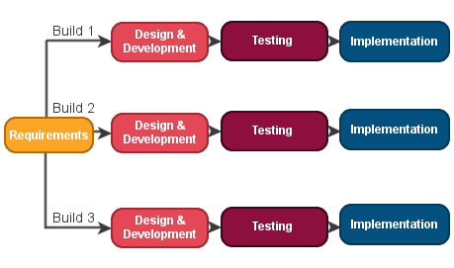

# 3.3 FEASIBILITY STUDY

#### All project are feasible – given unlimited resources and infinite time! Unfortunately, the development of computer-based system or product is more likely plagued by a scarcity of Resources and difficult delivery dates. It is both necessary and prudent to evaluate the feasibility of a project at the earliest possible time. Months or years of effect, thousands or millions of dollar, and untold professional embarrassment can be averted if an all-conceived system is recognized early in the definition phase.

#### Feasibility and risk analysis are related in many ways. If project risk is great the feasibility of producing quality software is reduced. During project engineering. However, we concentrate our attention on four primary areas of interest.

## Economic feasibility

#### In present system users need to place and booking ask question. So he/she needs to spend some time to complete this protocol. It is time consuming process sometimes users not able to spend that much of time.

#### If it is online consult vendor, he can ask question from anywhere in the world. No need to booking to for question of her query. For doing this process electronically have to spend some time.

## Technical Feasibility

#### This application in going to be used in internet environment called www(world wide web). So, it is necessary to use a technology that is capable of providing the networking facility to the application. This application as also able to work on distributed environment. Application on developed with J2ee with technology. One major advantage in application is platform neutral. We can deploy and used it in many operating system.

#### Guise developed using html to capture the information from the customer. Html IS used to display the content on the browser. It uses TCP/IP protocol. It is an interpreted language. It is very easy to develop a page/document using html some Red (rapid application development) tools are provided to quickly design/develop our application. So many objects such as button, text fields, and text area Etc. are providing to capture the information from the customer.

## Behavior feasibility

#### The new system can be beneficial only if it satisfies the parking requirements, in such a way the resource utilization and optimum outcome is justified. A new system should not only be reboots but should also be able to work simultaneously with other system Operational feasibility means that new system should not affect any existing system during the development phase or even in the implementation phase. Following are some point underlying the operational feasibility of the system-as the development processed many doubts got cleared out.

# 4. RISK IDENTIFICATION

# AND MANAGEMENT

#### **4.1 Risk Monitoring**

# 4.1 RISK MONITORING

#### Risk is defined as an exposure to the change of injury or loss. That is, risk implies that is a possibility that something negative may happen. In the context of software projects, negative implies that there is an adverse effect of cost, quality, or schedule.

#### Risk management is the area tries to ensure that the impact of risks on cost, quality and is minimal.

## Uncertainty

#### The risk may or happen that there are no 100% probable risk.

## Loss

#### If the become a risk reality, unwanted consequences or loss will occur when risk are analyzed, it is important to quantity the level of uncertainty and the degree of cost associate with each risk.

## Technical risk

#### The quality and timelines of the software to be produced. If a technical risk becomes reality, implementation may become difficult or impossible. Technical risks identify potential design, implementation, interface, verification and maintenance problem.

# 5. TECHNOLOGY USED

**Programming languages**

- PHP

- Codeigniter framework

- Html

- Java script

- Jquery

- Ajax

**Databases**

- Xemp server

- SQL server 2007

- MySQL

**Documentation Tools**

- EDraw

- MS Word

- MS Excel

- MS PowerPoint

**About PHP**

## Overview of PHP



#### PHP started out as a small open source project that evolved as more and more people found out how useful it was. Erasmus Leadoff unleashed the first version of PHP way back in 1994.

#### PHP is a recursive acronym for "PHP: Hypertext Preprocessor".

#### PHP is a server side scripting language that is embedded in HTML. It is used to manage dynamic content, databases, session tracking, even build entire e-commerce sites.

#### It is integrated with a number of popular databases, including MySQL, PostgreSQL, Oracle, Sybase, Informix, and Microsoft SQL Server.

#### PHP is pleasingly zippy in its execution, especially when compiled as an Apache module on the Unix side. The MySQL server, once started, executes even very complex queries with huge result sets in record-setting time.

#### PHP supports a large number of major protocols such as POP3, IMAP, and LDAP. PHP4 added support for Java and distributed object architectures (COM and CORBA), making n-tier development a possibility for the first time.

#### PHP is forgiving: PHP language tries to be as forgiving as possible.



## Common uses of PHP

#### PHP performs system functions, i.e. from files on a system it can create, open, read, write, and close them.

#### PHP can handle forms, i.e. gather data from files, save data to a file, through email you can send data, return data to the user.

#### You add, delete, modify elements within your database through PHP.

#### Access cookies variables and set cookies.

#### Using PHP, you can restrict users to access some pages of your website.

#### It can encrypt data.

## Features of PHP

**SIMPLE**

**FLEXIBILITY**

**EFFICIENCY**

**SIMPLICITY**

**INTERPRETED**

**PLATFORM INDEPENDENT**

**MORE FASTER**

**OPEN SOURCE**

#### It is most popular and frequently used worldwide scripting language, the main reason of popularity is; It is open source and very simple.

#### Simple

#### Faster

#### Interpreted

#### Open Source

#### Case Sensitive

#### Simplicity

#### Efficiency

#### Platform Independent

#### Security

#### Flexibility

#### Familiarity

### Simple

#### It is very simple and easy to use, compare to other scripting language it is very simple and easy, this is widely used all over the world.

### Interpreted

#### It is an interpreted language, i.e. there is no need for compilation.

### Faster

#### It is faster than other scripting language e.g. asp and jsp.

### Open Source

#### Open source means you no need to pay for use php, you can free download and use.

### Platform Independent

#### PHP code will be run on every platform, Linux, Unix, Mac OS X, Windows.

### Case Sensitive

#### PHP is case sensitive scripting language at time of variable declaration. In PHP, all keywords (e.g. if, else, while, echo, etc.), classes, functions, and user-defined functions are NOT case-sensitive.

# About Codeigniter



#### CodeIgniter is an application development framework, which can be used to develop websites, using PHP. It is an Open Source framework. It has a very rich set of functionality, which will increase the speed of website development work.

#### If you know PHP well, then CodeIgniter will make your task easier. It has a very rich set of libraries and helpers. By using CodeIgniter, you will save a lot of time, if you are developing a website from scratch. Not only that, a website built in CodeIgniter is secure too, as it has the ability to prevent various attacks that take place through websites

# About MySQL

## Over View of MySQL



### What is Database?

#### A database is a separate application that stores a collection of data. Each database has one or more distinct APIs for creating, accessing, managing, searching and replicating the data it holds.

#### Other kinds of data stores can also be used, such as files on the file system or large hash tables in memory but data fetching and writing would not be so fast and easy with those type of systems.

#### Nowadays, we use relational database management systems (RDBMS) to store and manage huge volume of data. This is called relational database because all the data is stored into different tables and relations are established using primary keys or other keys known as **Foreign Keys**.

#### A Relational Database Management System (RDBMS) is a software that −

#### Enables you to implement a database with tables, columns and indexes.

#### Guarantees the Referential Integrity between rows of various tables.

#### Updates the indexes automatically.

#### Interprets an SQL query and combines information from various tables.

## RDBMS Terminology

Before we proceed to explain the MySQL database system, let us revise a few definitions related to the database.

#### **Database** − A database is a collection of tables, with related data.

#### **Table** − A table is a matrix with data. A table in a database looks like a simple spreadsheet.

#### **Column** − One column (data element) contains data of one and the same kind, for example the column postcode.

#### **Row** − A row (= tuple, entry or record) is a group of related data, for example the data of one subscription.

#### **Redundancy** − Storing data twice, redundantly to make the system faster.

#### **Primary Key** − A primary key is unique. A key value cannot occur twice in one table. With a key, you can only find one row.

#### **Foreign Key** − A foreign key is the linking pin between two tables.

#### **Compound Key** − A compound key (composite key) is a key that consists of multiple columns, because one column is not sufficiently unique.

#### **Index** − an index in a database resembles an index at the back of a book.

#### **Referential Integrity** − Referential Integrity makes sure that a foreign key value always points to an existing row.

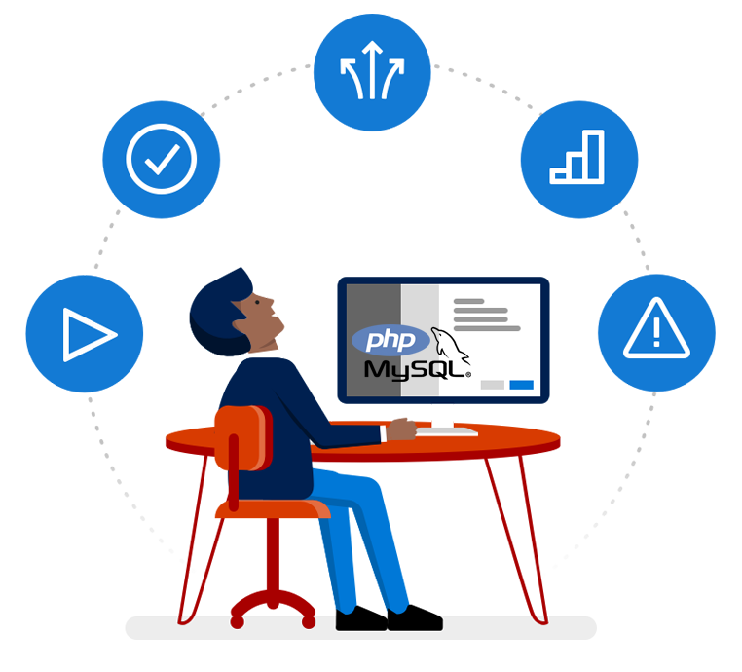

## MySQL Database

MySQL is a fast, easy-to-use RDBMS being used for many small and big businesses. MySQL is developed, marketed and supported by MySQL AB, which is a Swedish company. MySQL is becoming so popular because of many good reasons

#### MySQL is released under an open-source license. So you have nothing to pay to use it.

#### MySQL is a very powerful program in its own right. It handles a large subset of the functionality of the most expensive and powerful database packages.

#### MySQL uses a standard form of the well-known SQL data language.

#### MySQL works on many operating systems and with many languages including PHP, PERL, C, C++, JAVA, etc.

#### MySQL works very quickly and works well even with large data sets.

#### MySQL is very friendly to PHP, the most appreciated language for web development.

#### MySQL supports large databases, up to 50 million rows or more in a table. The default file size limit for a table is 4GB, but you can increase this (if your operating system can handle it) to a theoretical limit of 8 million terabytes (TB).

#### MySQL is customizable. The open-source GPL license allows programmers to modify the MySQL software to fit their own specific environments.

# About XAMPP

## C:\Users\ADMIN\Downloads\XAMPP_Windows_10.png

XAMPP is a free and open-source cross-platform web server solution stack package developed by Apache Friends consisting mainly of the Apache HTTP Server, Maria DB database, and interpreters for scripts written in the PHP and Perl programming languages. Since most actual web server deployments use the same components as XAMPP, it makes transitioning from a local test server to a live server possible.

XAMPP's ease of deployment means a WAMP or LAMP stack can be installed quickly and simply on an operating system by a developer, with the advantage a number of common add-in applications such as Word press and Joomla! can also be installed with similar ease using Bitnami .

# About HTML

****

#### HTML stands for Hyper Text Markup Language

#### HTML describes the structure of Web pages using markup

#### HTML elements are the building blocks of HTML pages

#### HTML elements are represented by tags

#### HTML tags label pieces of content such as "heading", "paragraph", "table", and so on

#### Browsers do not display the HTML tags, but use them to render the content of the page

## HTML Documents

#### All HTML documents must start with a document type declaration: <!DOCTYPE html>.

#### The HTML document itself begins with <html> and ends with </html>.

#### The visible part of the HTML document is between <body> and </body>.

# About Ajax



AJAX allows web pages to be updated asynchronously by exchanging small amounts of data with the server behind the scenes. This means that it is possible to update parts of a web page, without reloading the whole page. Classic web pages, (which do not use AJAX) must reload the entire page if the content should change. Examples of applications using AJAX: Google Maps, Gmail, YouTube, and Facebook tabs.

#### Ajax is not a programming language.

#### Ajax is a technique for accessing web servers from a web page.

#### Ajax stands for asynchronous javascript and xml.

# About Jquery



#### Jquery is not a language, but it is a well written JavaScript code.

#### Jquery greatly simplifies JavaScript programming.

#### Jquery is easy to learn.

#### As quoted on official jquery website, "it is a fast and concise JavaScript Library that simplifies HTML document traversing, event handling, animating, and Ajax interactions for rapid web development."

#### In order to work with Jquery, you should be aware of the basics of JavaScript, HTML and CSS.

#### It was released in January 2006 at Bar Camp NYC by John Resign.

# 6. SYSTEM PLANING

#### **6.1 Requirements Gathering**

#### **6.2 Time Line Chart**

## 6.1 REQUIREMENTS GATHERING

#### System requirements are expressed in a software requirement document the software requirement specification is the official statement or what is required of the system for developers. this requirements document includes the requirement definition and the requirement specification. The software requirements document is not a design document. It should set out what the system should do without specifying how it should be done. The requirement set out this document is complete and consist.

#### The software specification document satisfies the following

#### It specifies the external system behaviors.

#### It specifies constrains on the implementation.

#### It is easy to change.

#### It server as reference tool for system.

#### It records forethought about the life cycle of the system.

6.2 Time Line Chart

|  |  |  |  |  |  |  |  |  |  |  |  |  |  |  |
| --- | --- | --- | --- | --- | --- | --- | --- | --- | --- | --- | --- | --- | --- | --- |
| Week | 1 | 2 | 3 | 4 | 5 | 6 | 7 | 8 | 9 | 10 | 11 | 12 | 13 | 14 |
| Day | 1 | 6 | 13 | 20 | 27 | 3 | 10 | 17 | 24 | 2 | 9 | 16 | 23 | 30 |
| Month  Activity | January | | | | | February | | | | March | | | | |
| Domain  Under standing |  |  |  |  |  |  |  |  |  |  |  |  |  |  |
| Further  Analysis |  |  |  |  |  |  |  |  |  |  |  |  |  |  |
| Learning  Process |  |  |  |  |  |  |  |  |  |  |  |  |  |  |
| Design |  |  |  |  |  |  |  |  |  |  |  |  |  |  |
| Coding |  |  |  |  |  |  |  |  |  |  |  |  |  |  |
| Testing |  |  |  |  |  |  |  |  |  |  |  |  |  |  |
| Document-  Ation |  |  |  |  |  |  |  |  |  |  |  |  |  |  |

# 7. SYSTEM ANALYSIS

#### **7.1 ER-Diagram**

#### **7.2 Data-Flow Diagram**

#### **7.3 Data Dictionary**

7.1 ER-DIAGRAM

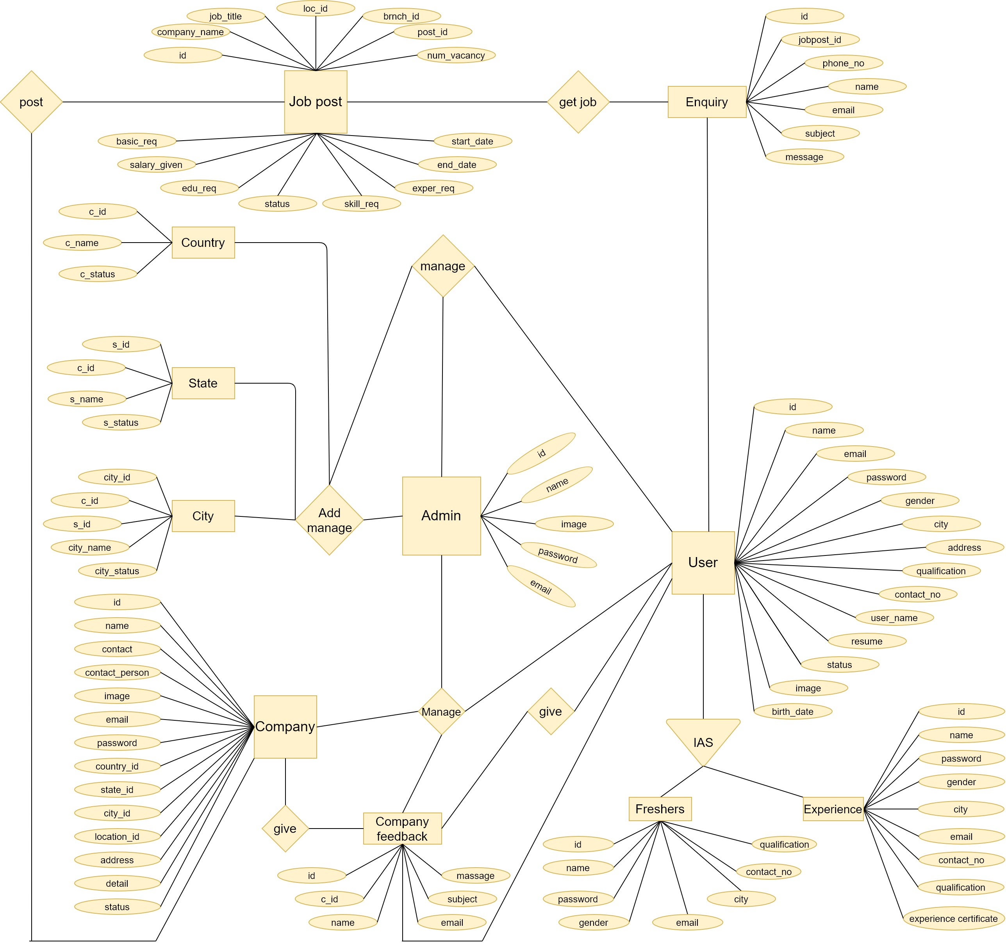

7.2 DATA-FLOW DIAGRASM

## Context level data flow diagram

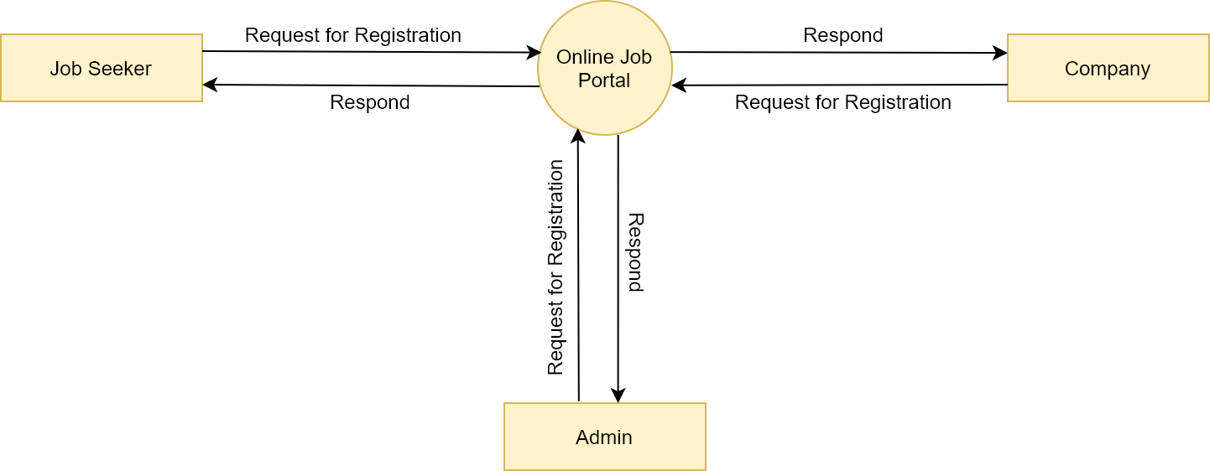

* First level DFD

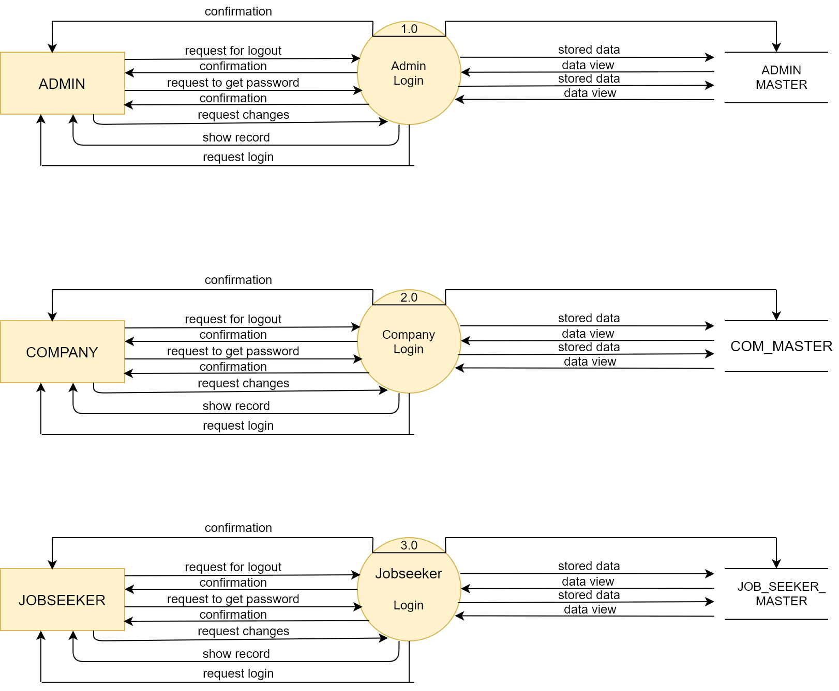

* Second Level DFD Of Admin

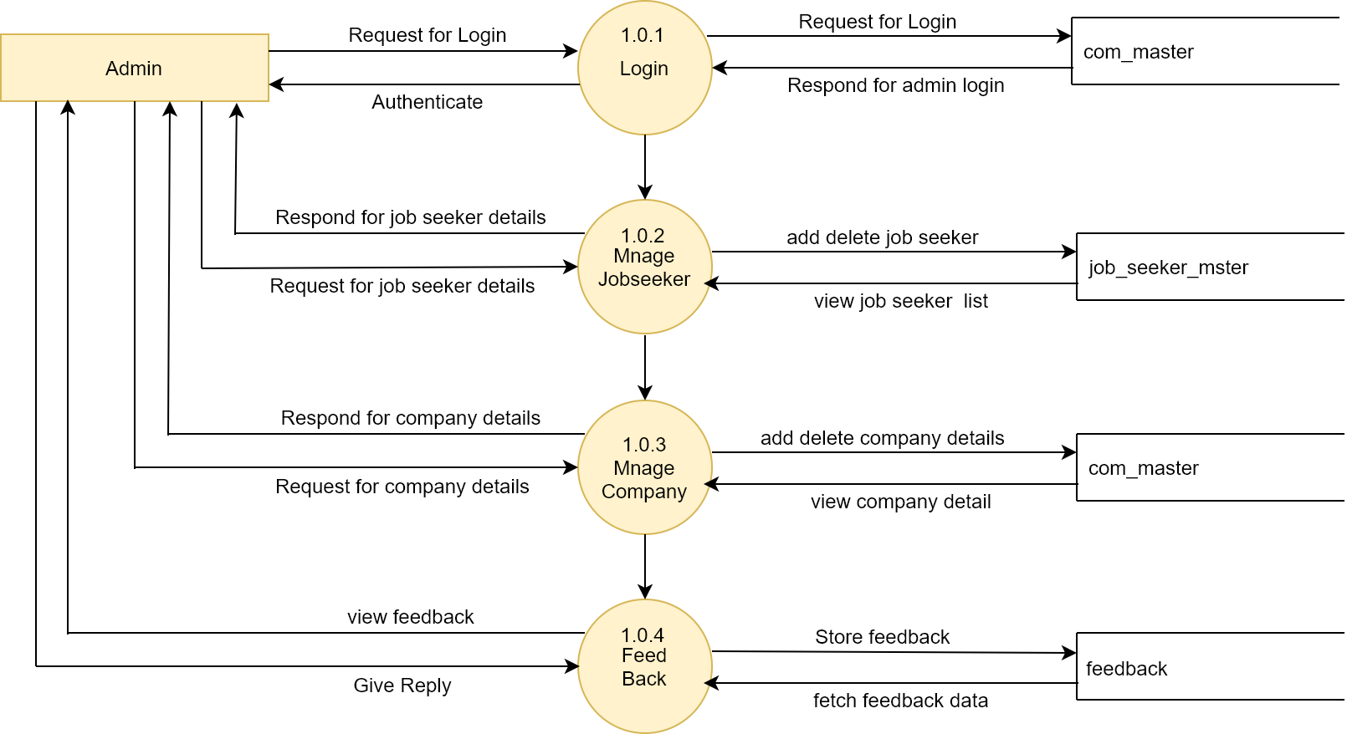

* Second Level DFD Of Company

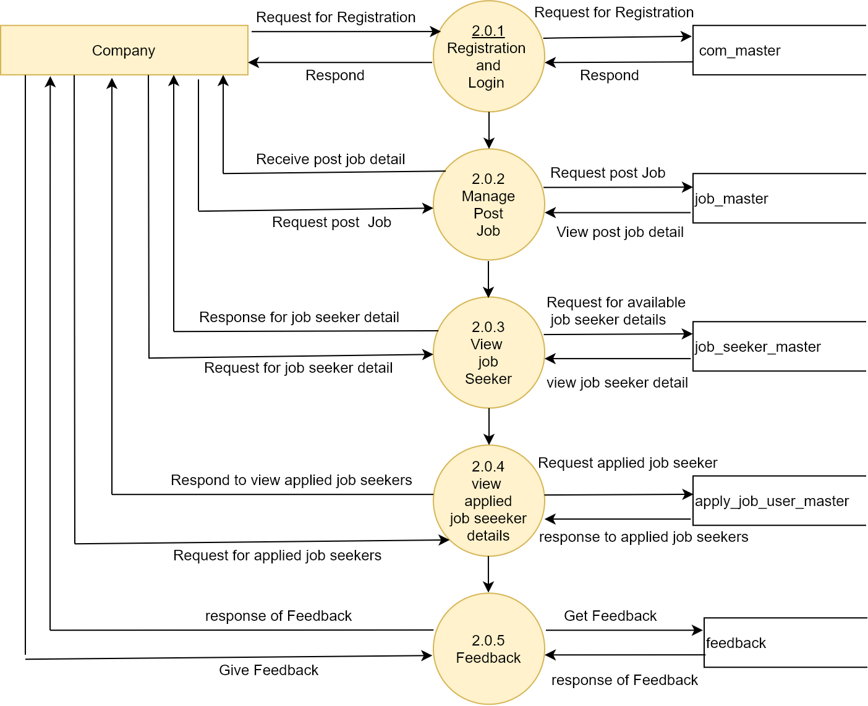

* Second Level DFD Of Job Seeker

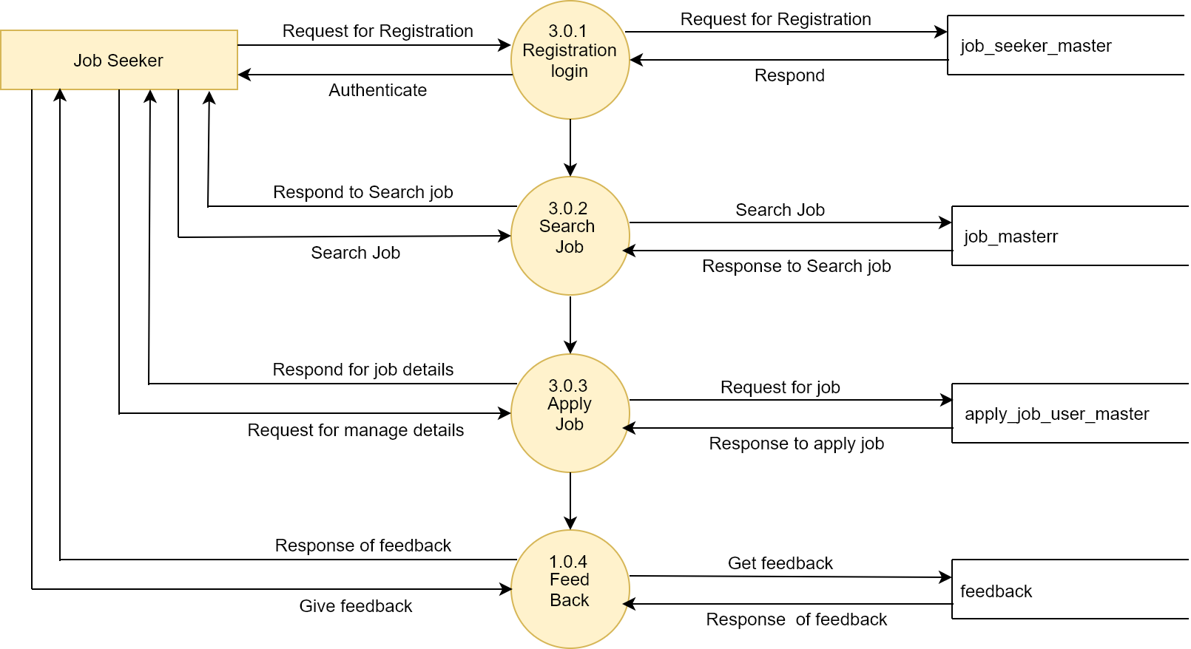

7.3 Data Dictionary

#### **Admin**

|  |  |  |  |
| --- | --- | --- | --- |
| Field name | Type | Constraint | Description |
| Id | Int | AUTO\_INCREMENT(primary key) | It is unique number |
| Name | Varchar | Not null | It is name of admin |
| Email | Varchar | Not null | It is email of admin |
| Password | Varchar | Not null | It is password of admin |
| Image | Text | Not null | It is image of admin |

#### **Category**

|  |  |  |  |
| --- | --- | --- | --- |
| Field name | Type | Constraint | Description |
| Id | Int | AUTO\_INCREMENT(primary key) | It is unique number |
| Name | Varchar | Not null | It is name of category |
| Description | varchar | Not null | Description |

* **Country**

|  |  |  |  |
| --- | --- | --- | --- |
| Field name | Type | Constraint | Description |
| Id | int | AUTO\_INCREMENT(primary key) | It is unique number |
| country\_name | Varchar | Not null | It display country |
| country\_status | Varchar | Not null | Active/diactive |

* **State**

|  |  |  |  |
| --- | --- | --- | --- |
| Field name | Type | Constraint | Description |
| Id | int | AUTO\_INCREMENT(primary key) | It is unique number |
| State\_name | Varchar | Not null | It display State |
| State\_status | Varchar | Not null | Active/diactive |

* **City**

|  |  |  |  |
| --- | --- | --- | --- |
| Field name | Type | Constraint | Description |
| Id | Int | AUTO\_INCREMENT(primary key) | It is unique number |
| State\_id | Int | Foreign key | It display stateid of city |
| City\_name | Varchar | Not null | It is Cityname of city table |
| city\_status | Varchar | Not null | Active/diactive |

* **Location**

|  |  |  |  |
| --- | --- | --- | --- |
| Field name | Type | Constraint | Description |
| Id | Int | AUTO\_INCREMENT(primary key) | It is unique number |
| City\_id | Int | Foreign key | It is cityid of location |
| Location | Varchar | Not null | It display location |
| Location\_status | Varchar | Not null | Active/diactive |

* **Education**

|  |  |  |  |
| --- | --- | --- | --- |
| Field name | Type | Constraint | Description |
| Id | Int | AUTO\_INCREMENT(primary key) | It is unique number |
| Name | Varchar | Not null | It is name of degree |

* **Post**

|  |  |  |  |
| --- | --- | --- | --- |
| Field name | Type | Constraint | Description |
| Id | Int | AUTO\_INCREMENT(primary key) | It is unique number |
| Name | Varchar | Not null | It is name of post |
| Category \_id | Varchar | Not null | It is category of post |

* **Skill**

|  |  |  |  |
| --- | --- | --- | --- |
| Field name | Type | Constraint | Description |
| Id | Int | AUTO\_INCREMENT(primary key) | It is unique number |
| Name | Varchar | Not null | It is name of skill |

* **Company**

|  |  |  |  |
| --- | --- | --- | --- |
| Field name | Type | Constraint | Description |
| Id | int | AUTO\_INCREMENT(primary key) | It is unique number |
| Name | Varchar | Foreign key | It display company name |
| Contact | bigint | Not null | It display company number |
| Contact person | varchar | Not null | It display the name of the person |
| Image | varchar | Not null | It display images of company |
| Email | varchar | Not null | It is display email |
| Password | varchar | Not null | It display password |
| Country\_id | int | Foreign key | It display country |
| State\_id | int | Foreign key | It display state |
| City\_id | int | Foreign key | It display city |
| Location\_id | int | Foreign key | It display location |
| Address | varchar | Not null | It display address |
| Details | varchar | Not null | It display details |
| Status | varchar | Not null | It display status |

* **Company branch**

|  |  |  |  |
| --- | --- | --- | --- |
| Field name | Type | Constraint | Description |
| Id | int | AUTO\_INCREMENT(primary key) | It is unique number |
| Name | Varchar | Foreign key | It display company name |
| Country\_id | int | Foreign key | It display country |
| State\_id | int | Foreign key | It display state |
| City\_id | int | Foreign key | It display city |
| Location\_id | int | Foreign key | It display location |
| Address | varchar | Not null | It display address |

* **Job post**

|  |  |  |  |
| --- | --- | --- | --- |
| Field name | Type | Constraint | Description |
| Id | int | AUTO\_INCREMENT(primary key) | It is userid of users |
| Company\_name | Varchar | Foreign key | It is name of company |
| Job\_title | Varchar | Not null | It is title of job |
| Loc\_id | int | Not null | It is location |
| Branch\_id | int | Not null | It is branch of company |
| Post\_id | int | Not null | It is post of job |
| Num\_vacancy | int | Not null | It is vacancy |
| Start\_date | date | Not null | It display start date |
| End\_date | date | Not null | It display end date |
| Exper\_req | int | Not null | Experience |
| Skill\_req | varchar | Not null | Skill |
| Basic\_req | varchar | Not null | Basic requirement |
| Salary\_given | int | Not null | Salary given |
| Status | varchar | Not null | Active/diative |
| Edu\_req | varchar | Not null | Degree\_name |

* **Course video**

|  |  |  |  |
| --- | --- | --- | --- |
| Field name | Type | Constraint | Description |
| Id | Int | AUTO\_INCREMENT(primary key) | It is unique number |
| Course\_id | int | Foreign key | It is name of course |
| Video | Varchar | Not null | It is video of course |

* **Course**

|  |  |  |  |
| --- | --- | --- | --- |
| Field name | Type | Constraint | Description |
| Id | Int | AUTO\_INCREMENT(primary key) | It is unique number |
| Course\_Name | Varchar | Not null | It is name of course |
| Cousre\_pic | Varchar | Not null | It is image of course |
| Course Attechment | Varchar | Not null | It is attachment file of course |
| Category | Int | Not null | Category of Course |
| Description | Varchar | Not null | Description |
| Content | Varchar | Not null | Content of Course |

* **Workshop**

|  |  |  |  |
| --- | --- | --- | --- |
| Field name | Type | Constraint | Description |
| Id | Int | AUTO\_INCREMENT(primary key) | It is unique number |
| workshop Title | Varchar | Not null | It is name of workshop |
| Workshop pic | Varchar | Not null | It is image of Workshop |
| Company | Int | Not null | Company Name |
| Category | Int | Not null | Category of Workshop |
| Description | Varchar | Not null | Description |
| Start Time | Time | Not null | Start Time of workshop |
| End Time | Time | Not null | End Time of workshop |
| Start Date | Date | Not null | Start date |
| End Date | Date | Not null | End date |
| Venue | Varchar | Not null | Venue of Workshop |
| Creation Date | Time stremp | Not null | Creation date |

* **Workshop Gallery**

|  |  |  |  |
| --- | --- | --- | --- |
| Field name | Type | Constraint | Description |
| Id | Int | AUTO\_INCREMENT(primary key) | It is unique number |
| Workshop\_id | Int | Not null | It is name of workshop |
| Workshop\_pic | Varchar | Not null | It is image |

* **Workshop Video**

|  |  |  |  |
| --- | --- | --- | --- |
| Field name | Type | Constraint | Description |
| Id | Int | AUTO\_INCREMENT(primary key) | It is unique number |
| Workshop\_id | Int | Not null,ForiegnKey | It’s workshop id |
| Workshop Video | Varchar | Not null | Video of workshop |

* **Workshop Feedback**

|  |  |  |  |
| --- | --- | --- | --- |
| Field name | Type | Constraint | Description |
| Id | Int | AUTO\_INCREMENT(primary key) | It is unique number |
| Workshop\_id | Int | Not null,ForiegnKey | It’s workshop id |
| User\_id | Int | Not null | user id |
| Name | Varchar | Not null | Name of user |
| Email | Varchar | Not null | Email of user |
| Subject | Varchar | Not null | Subject of feedback |
| Message | Varchar | Not null | Message |

* **Feedback**

|  |  |  |  |
| --- | --- | --- | --- |
| Field name | Type | Constraint | Description |
| Id | Int | AUTO\_INCREMENT(primary key) | It is unique number |
| Rating | Int | Not null | Rating of site |
| Name | Varchar | Not null | Name of user |
| Email | Varchar | Not null | Email of user |
| Subject | Varchar | Not null | Subject of feedback |
| Message | Varchar | Not null | Message |
| Contact\_num | Bigint | Not null | Mobile number |

* **Company Feedback**

|  |  |  |  |
| --- | --- | --- | --- |
| Field name | Type | Constraint | Description |
| Id | Int | AUTO\_INCREMENT(primary key) | It is unique number |
| com\_id | Int | Not null,ForiegnKey | It’s company id |
| Name | Varchar | Not null | Name of user |
| Email | Varchar | Not null | Email of user |
| Subject | Varchar | Not null | Subject of feedback |
| Message | Varchar | Not null | Message |

* **Enquiry**

|  |  |  |  |
| --- | --- | --- | --- |
| Field name | Type | Constraint | Description |
| Id | Int | AUTO\_INCREMENT(primary key) | It is unique number |
| jobpost\_id | Int | Not null,ForiegnKey | It’s jobpost id |
| Contact Number | Bigint | Not null | Phone Number |
| Name | Varchar | Not null | Name of user |
| Email | Varchar | Not null | Email of user |
| Subject | Varchar | Not null | Subject of feedback |
| Message | Varchar | Not null | Message |

* **User**

|  |  |  |  |
| --- | --- | --- | --- |
| Field name | Type | Constraint | Description |
| Id | Int | AUTO\_INCREMENT(primary key) | It is unique number |
| Name | Varchar | Not null | Name of user |
| Email | Varchar | Not null | Email of user |
| Password | Varchar | Not null | Password of user |
| Gender | Varchar | Not null | Gender Of User |
| Address | Varchar | Not null | Address of user |
| City | Varchar | Not null | City of User |
| Qualification | Varchar | Not null | Degree of user |
| **Contact\_num** | Bigint | Not null | Mobile Number |
| User Name | Varchar | null | User name |
| Reaume | Varchar | Not null | Resume of user |
| Status | Varchar | Null | Status of user |
| Image | Varchar | Null | Image of user |
| Birth Date | Date | Not null | Birth date of user |

# 8. SYSTEM DESIGN

**8.1 User Interface**

**8.2 Database Design**

8.1 User Interface

#### User Home Page:

### 

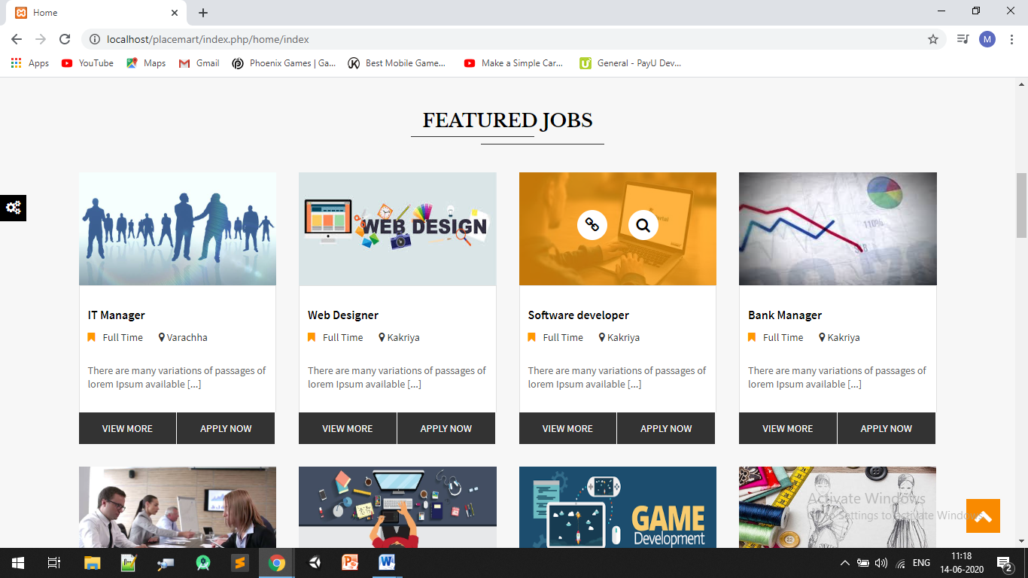

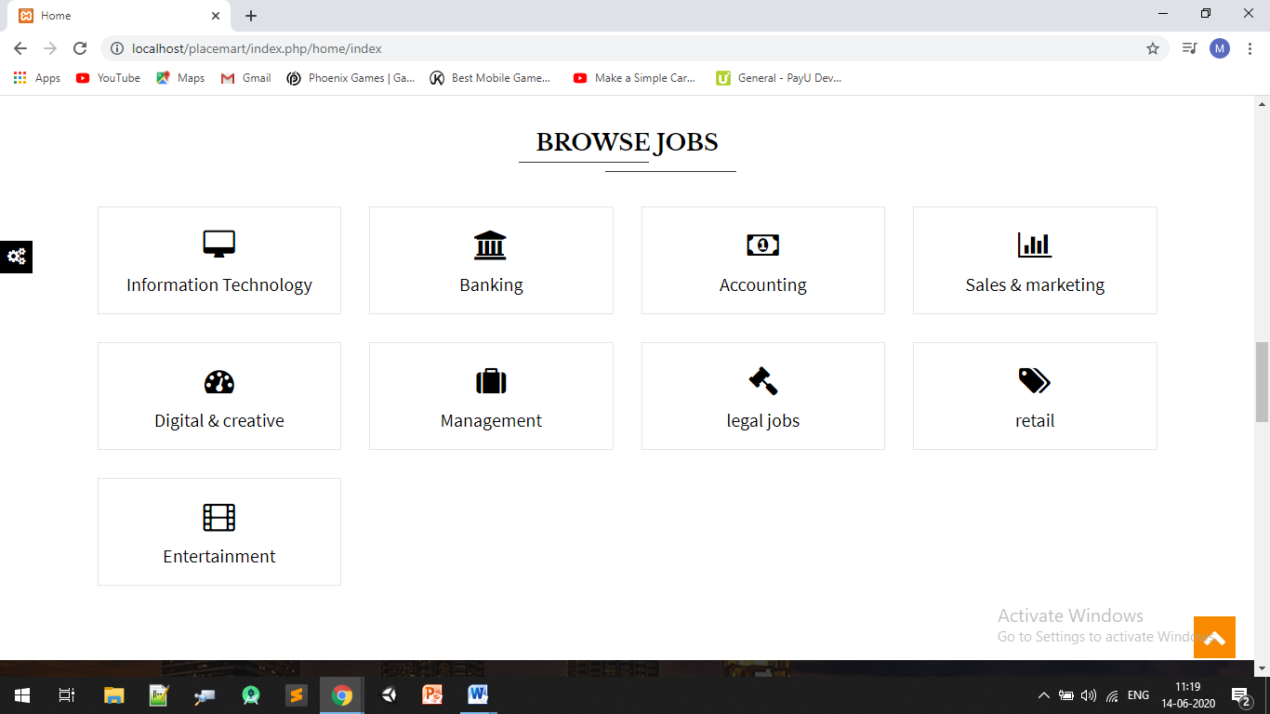

#### User Registration:

#### 

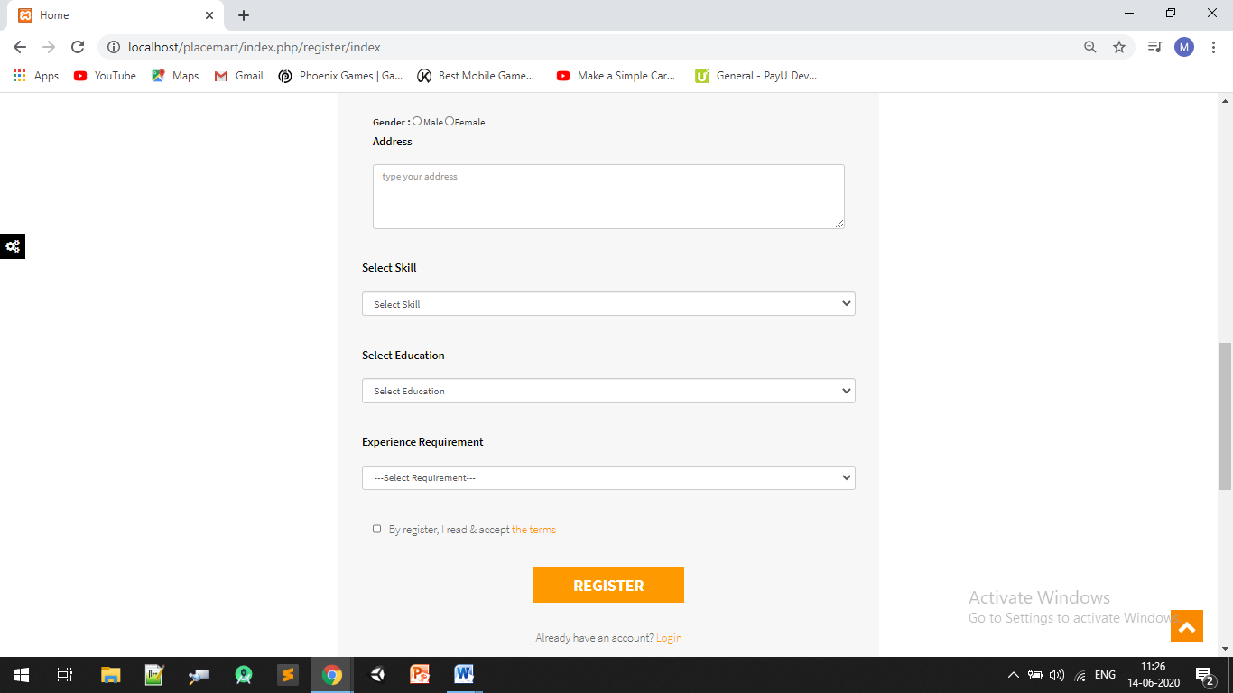

#### User Login:-

#### 

#### Edit Profile:

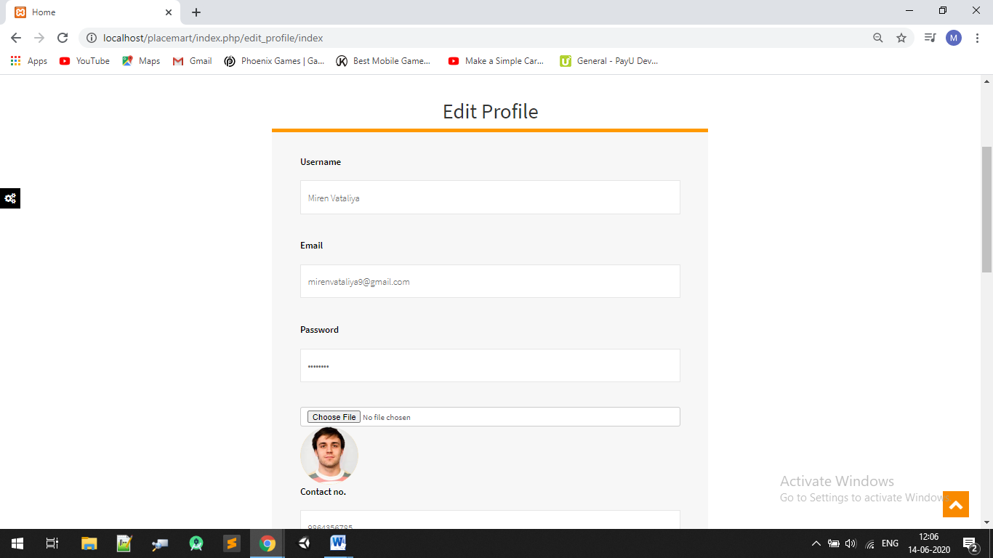

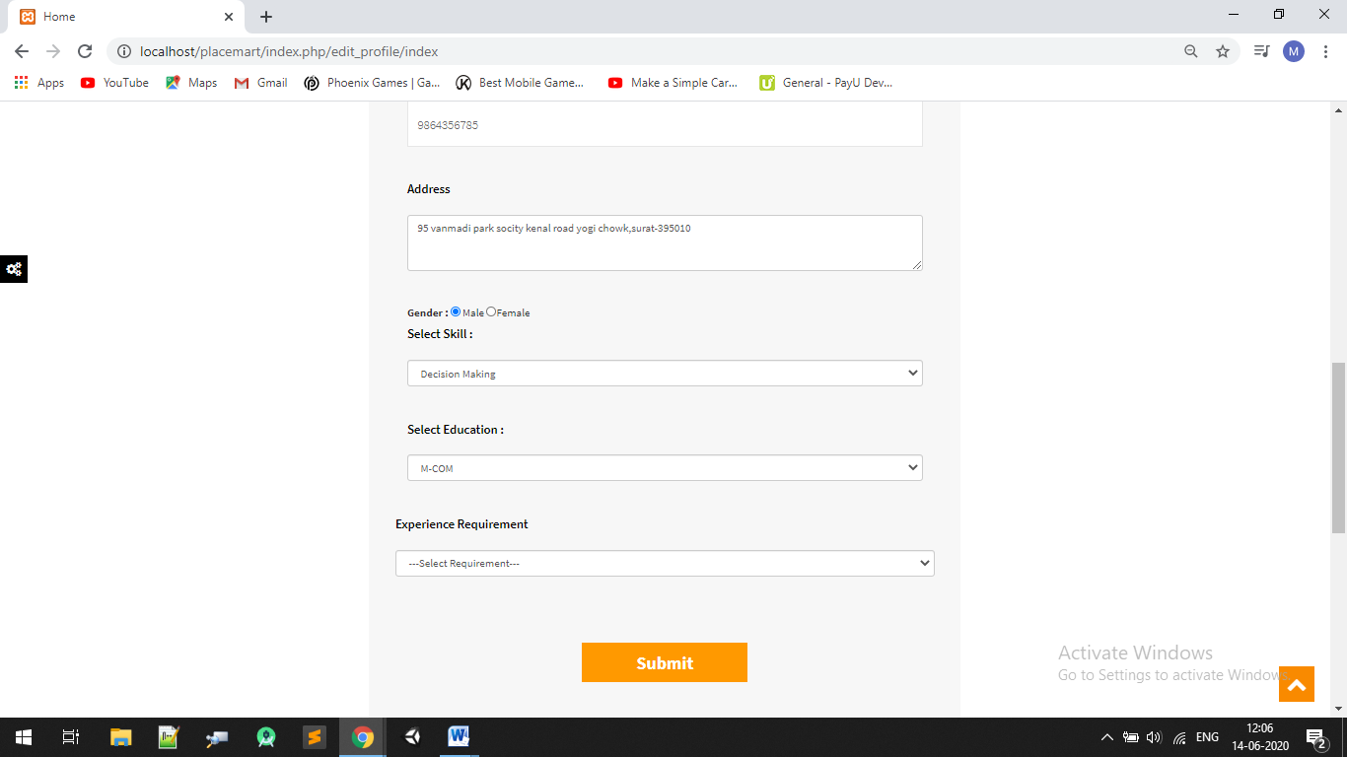

#### Change Password:

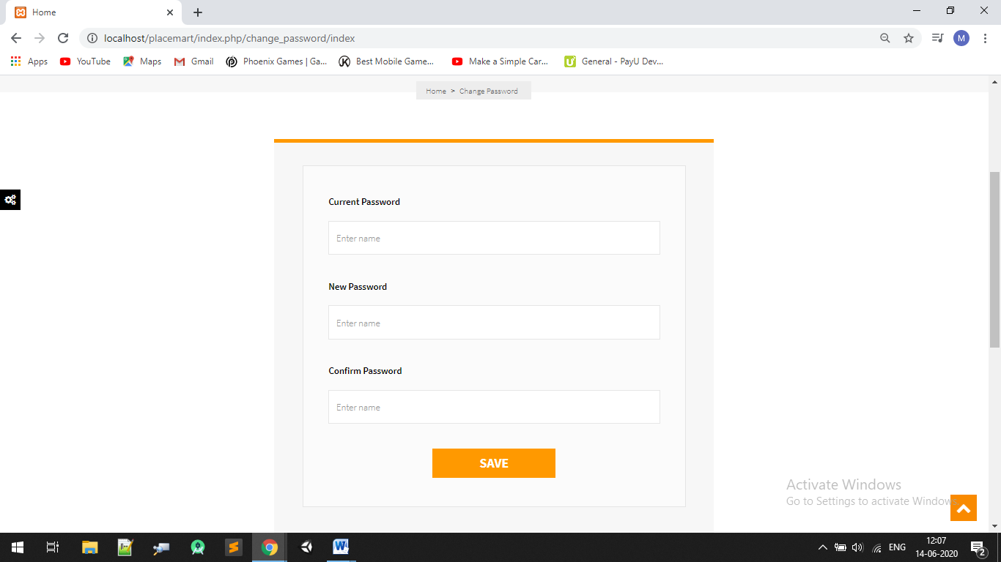

#### Forgot Password:



#### Send Password Using Mail.

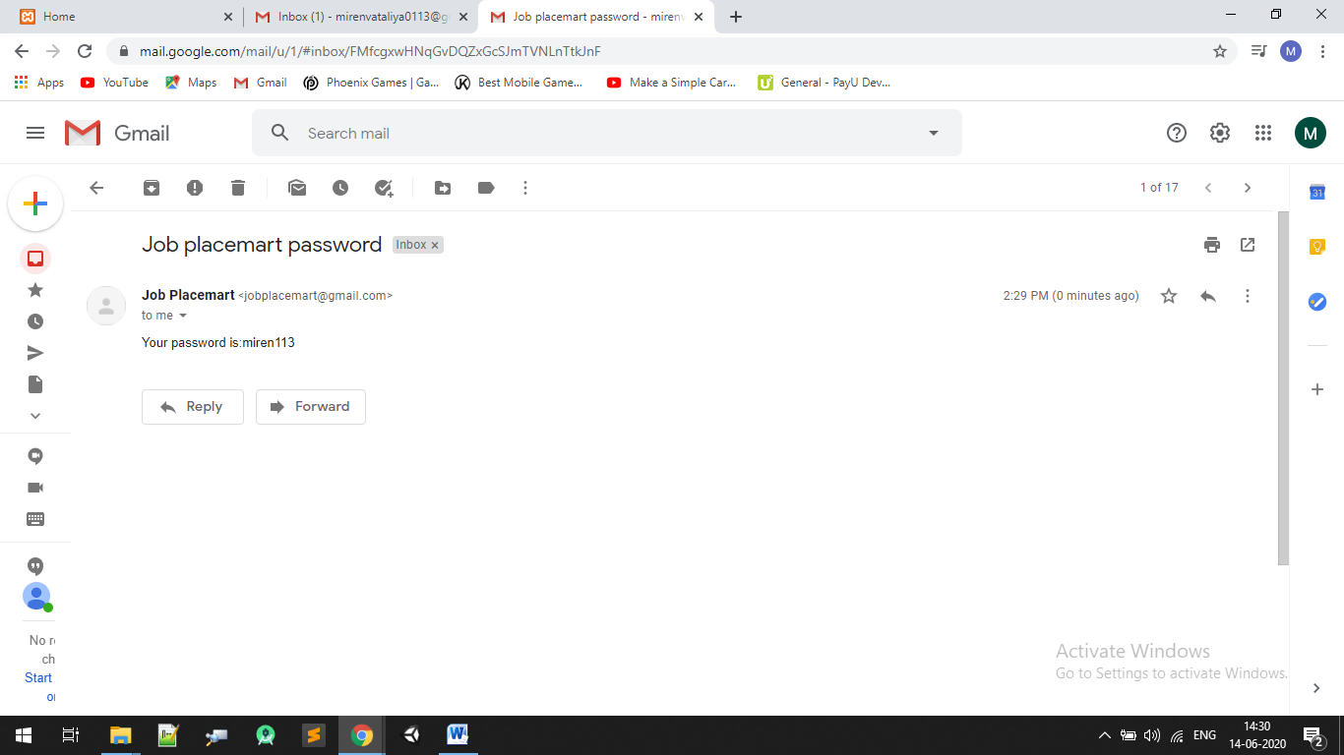

#### Job Page:

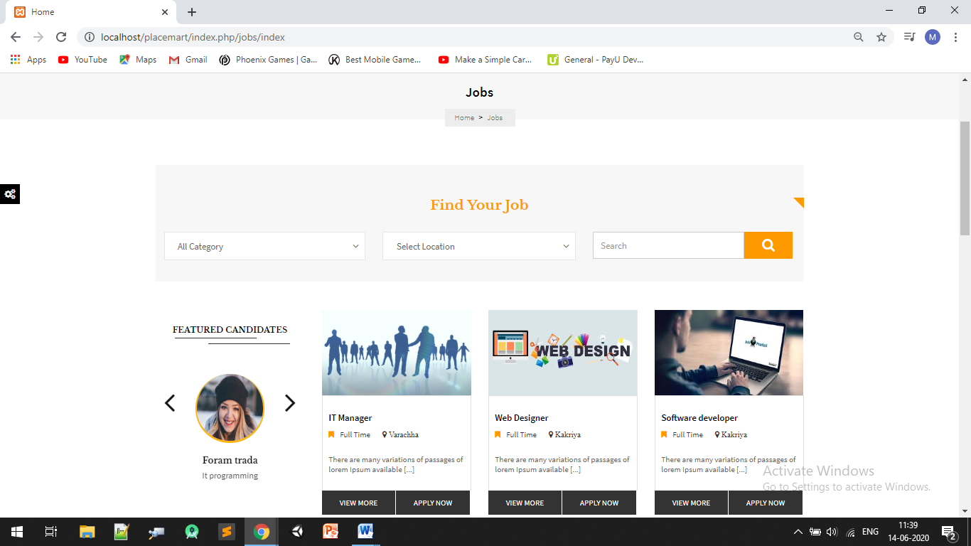

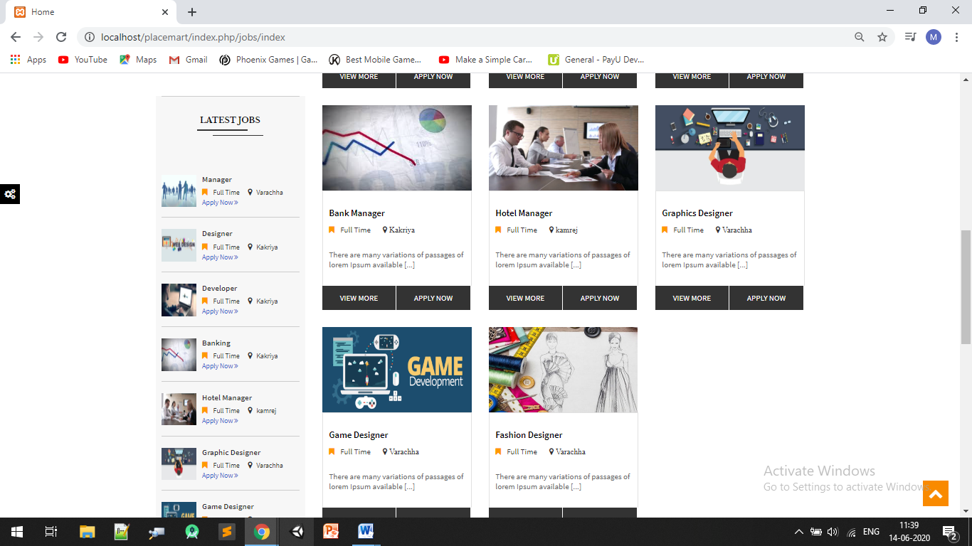

#### Apply Now Job Page:

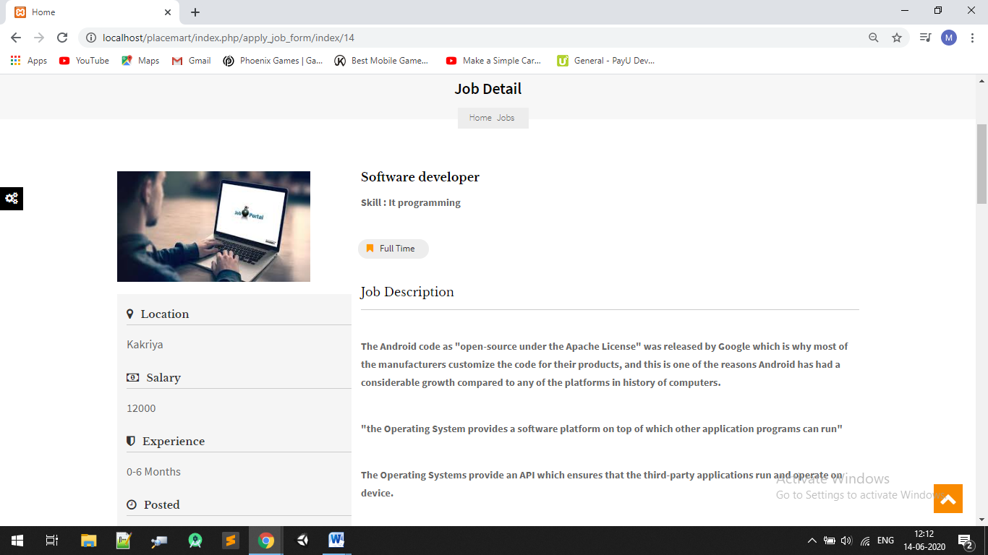

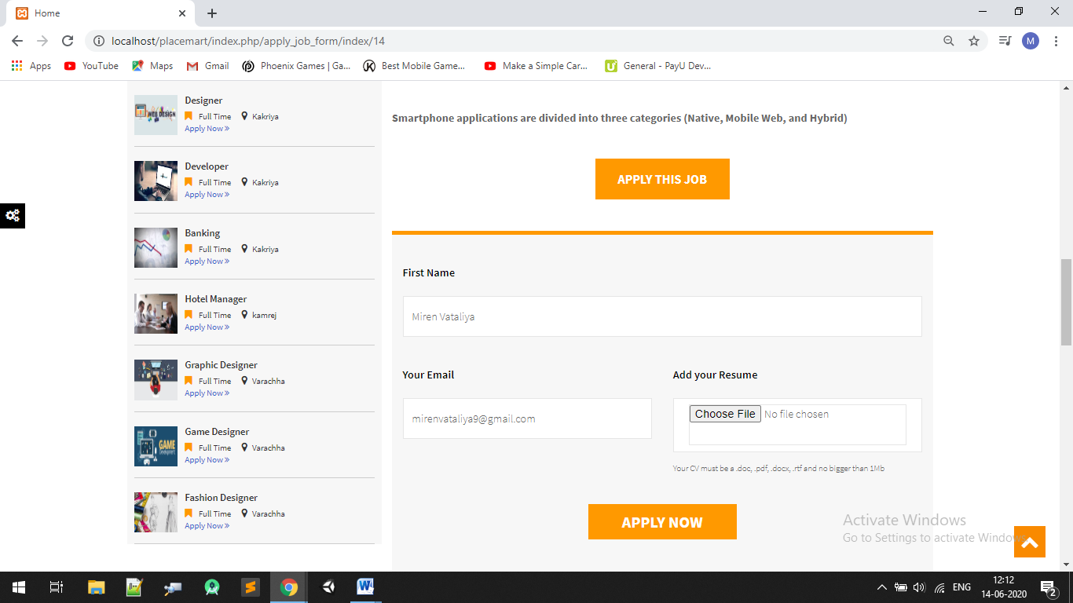

#### Inform to Admin and Company Using Mail

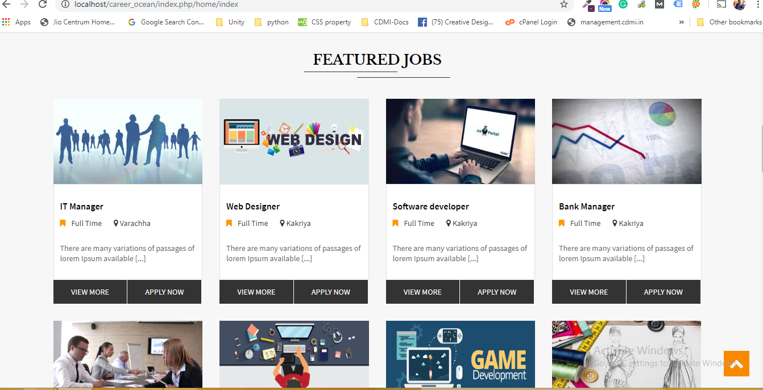

#### View More Company Detail:

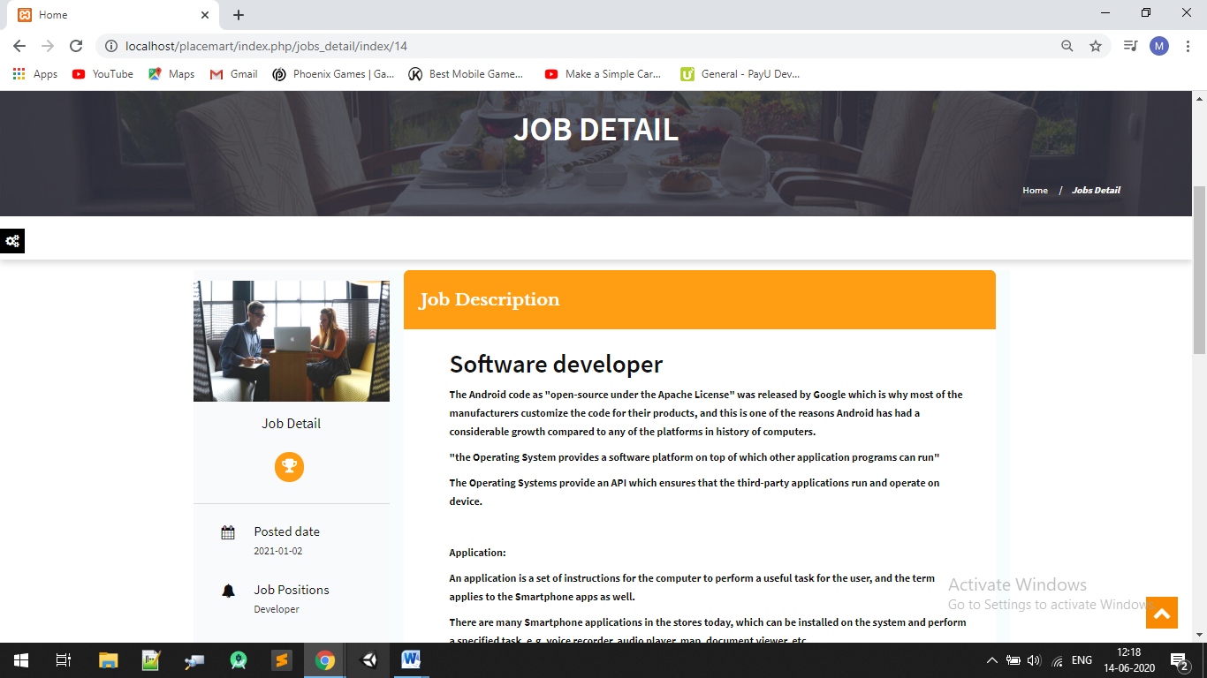

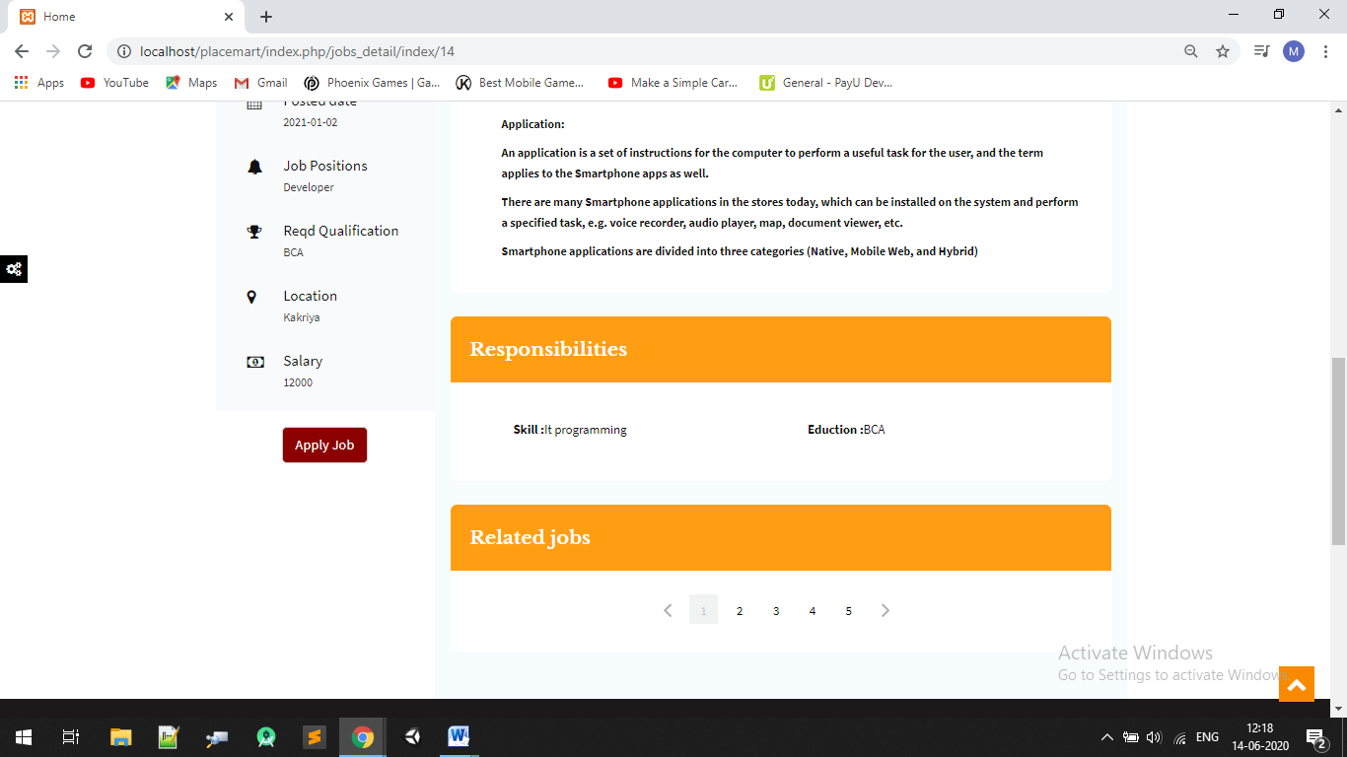

#### Candidates Page:

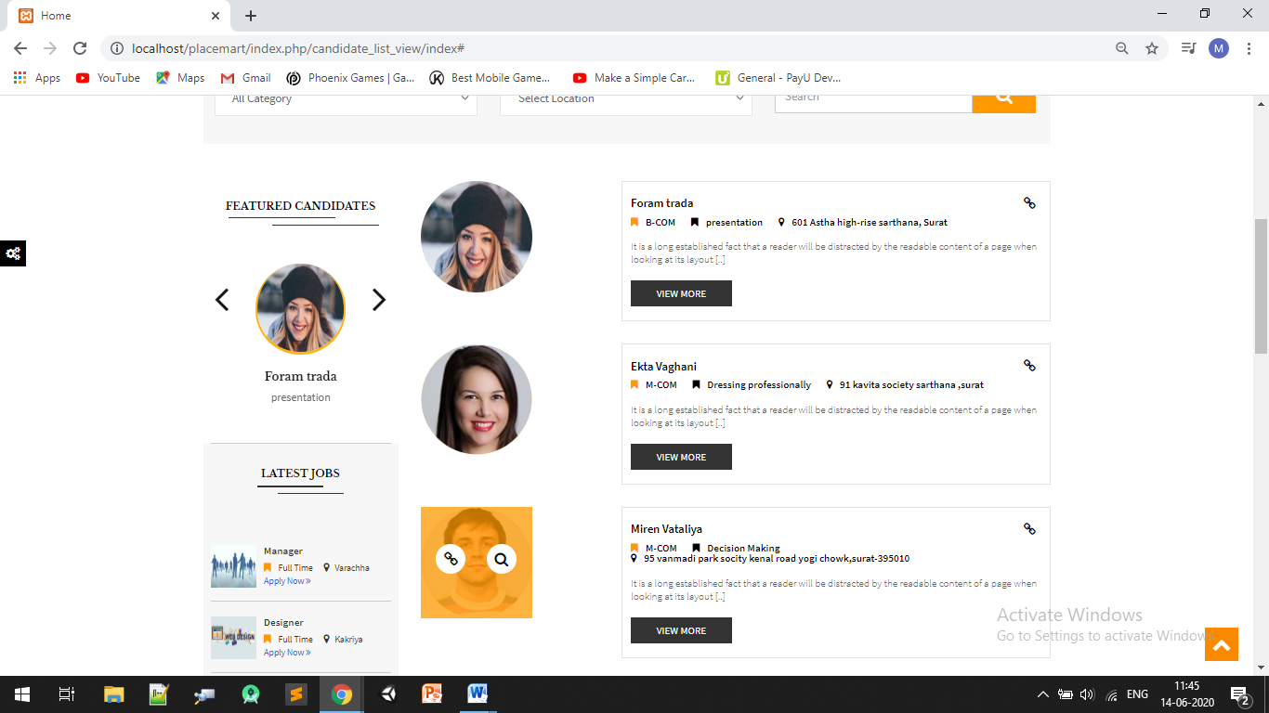

#### My Profile:

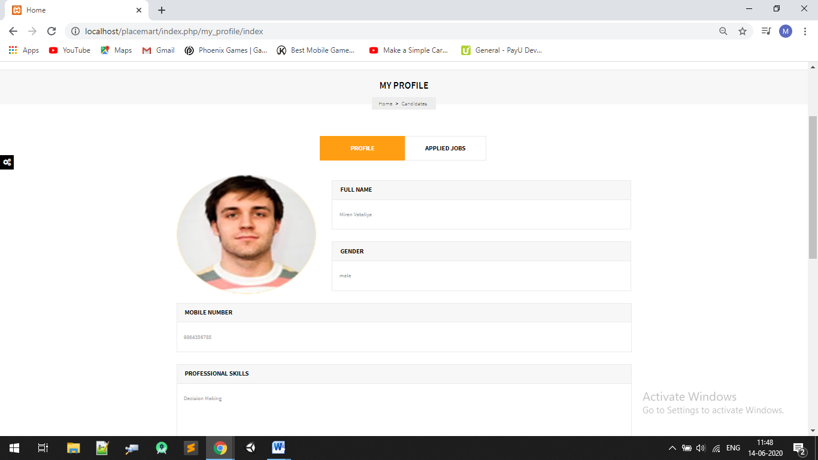

#### Applied Job:

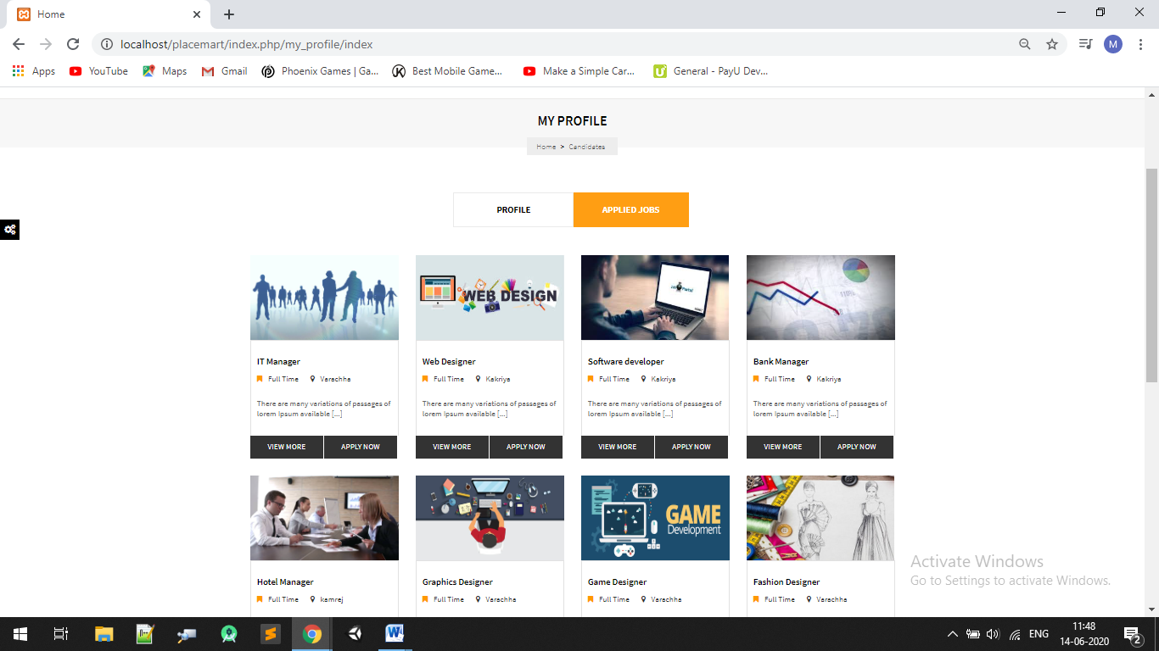

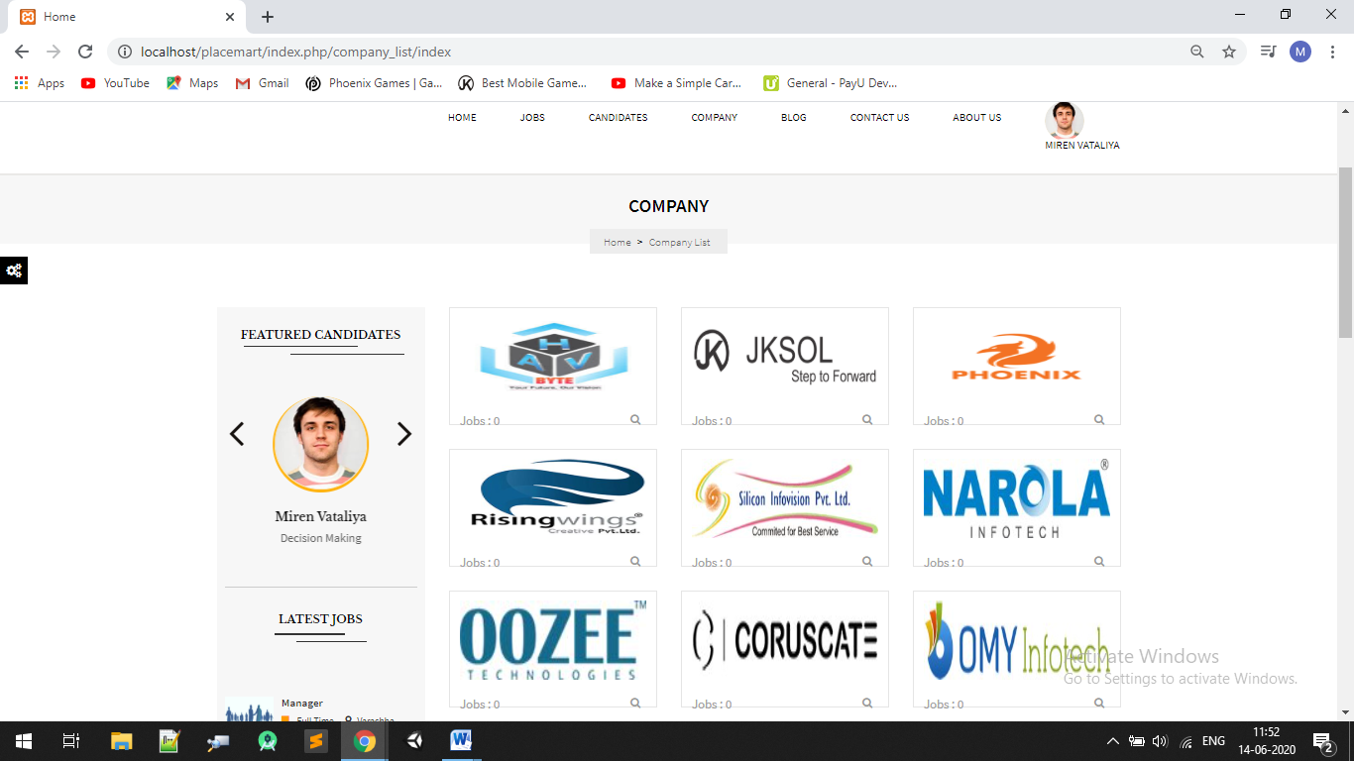

#### Company Page:

#### Blog Page:

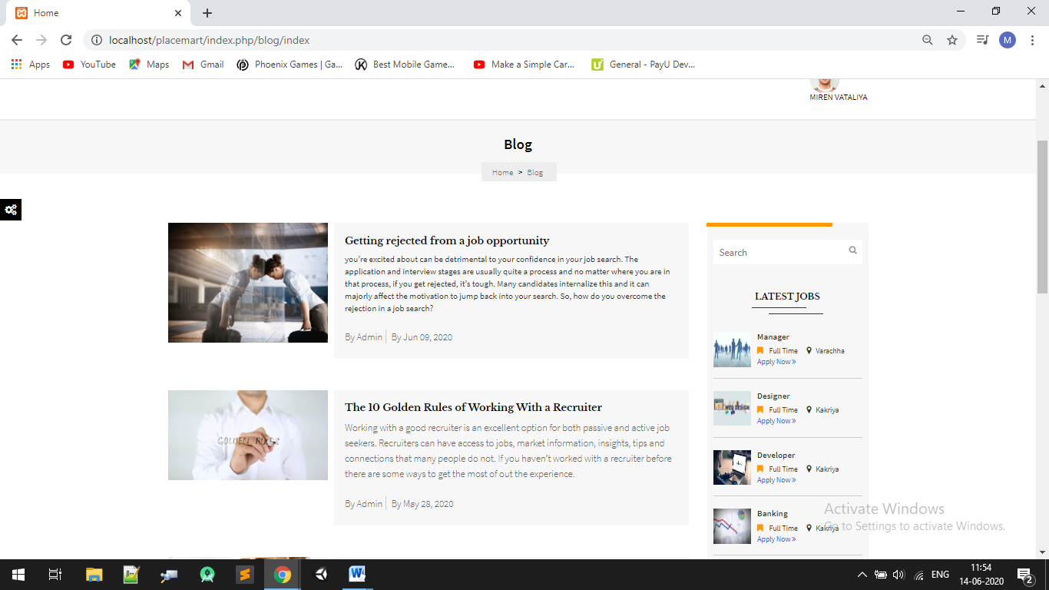

#### Blog Detail Page:

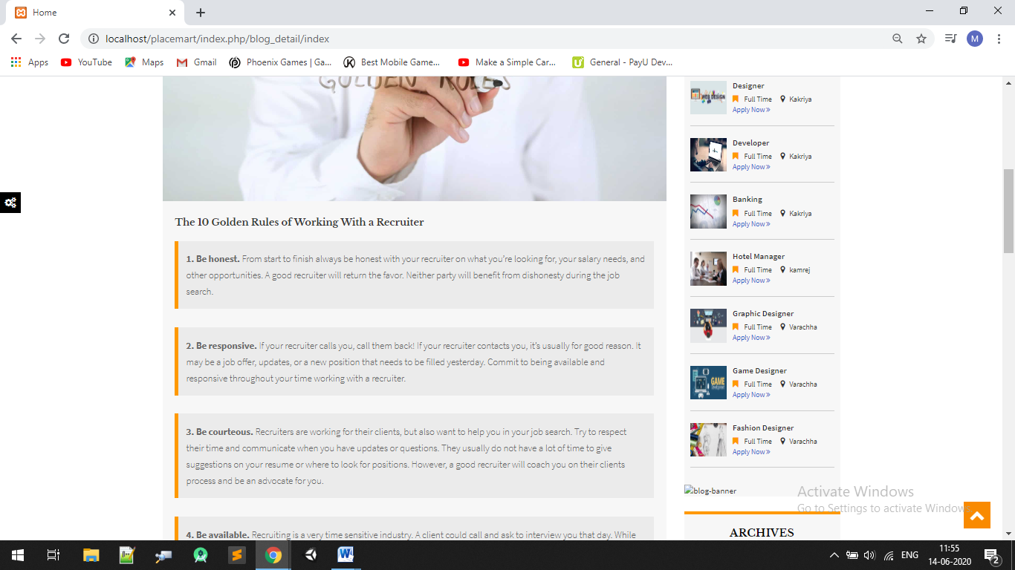

#### Contact Us:

#### 

#### About us Page:

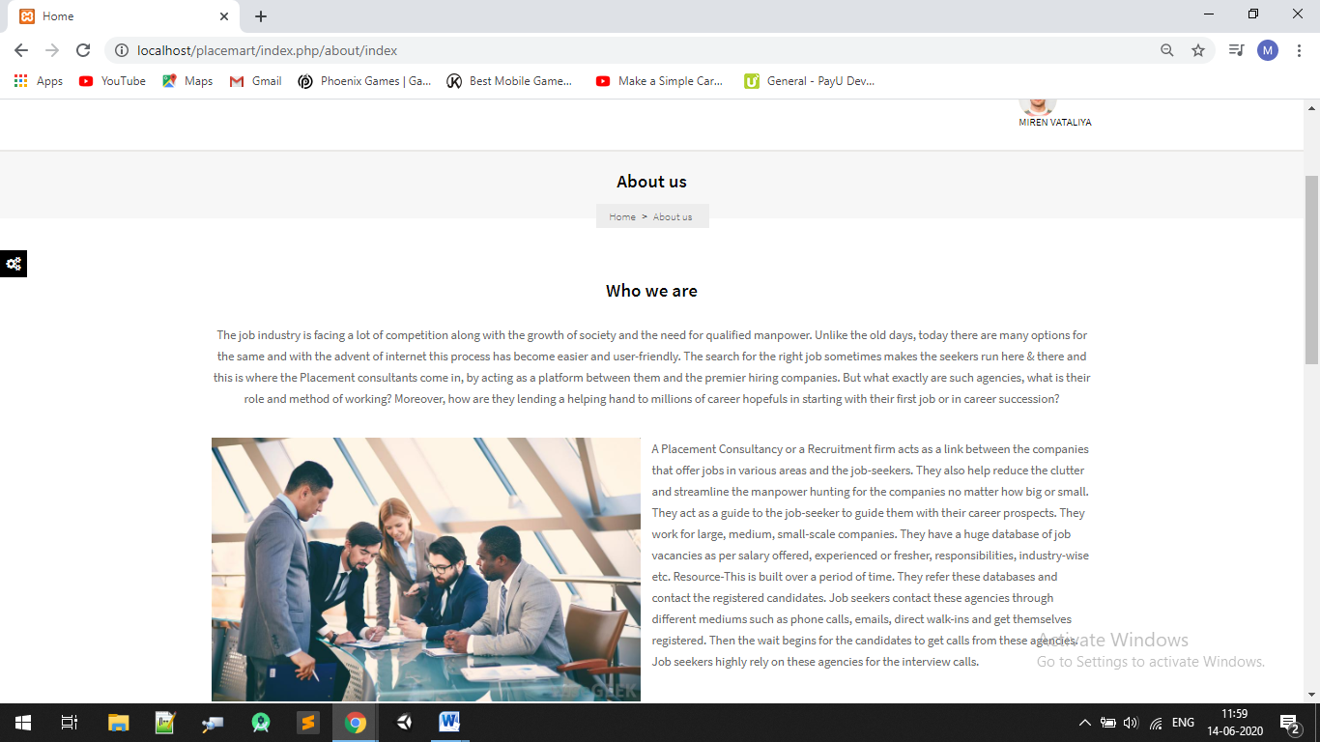

#### 

8.2 Database Design

### Admin Side :

#### Admin login page:

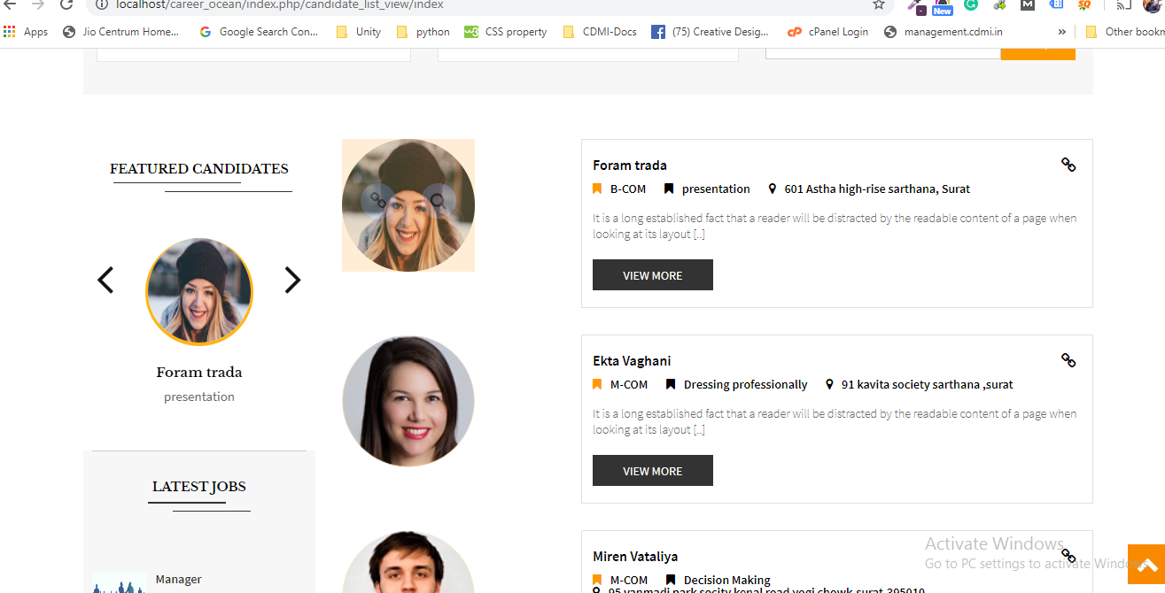

#### Admin Dashboard:

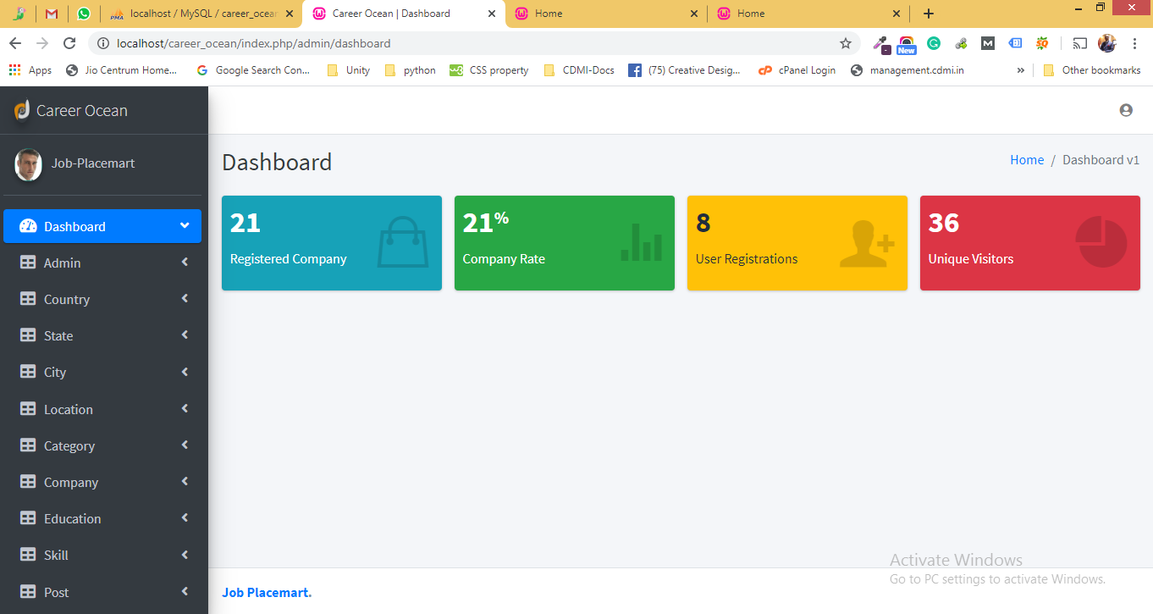

#### Edit Profile:

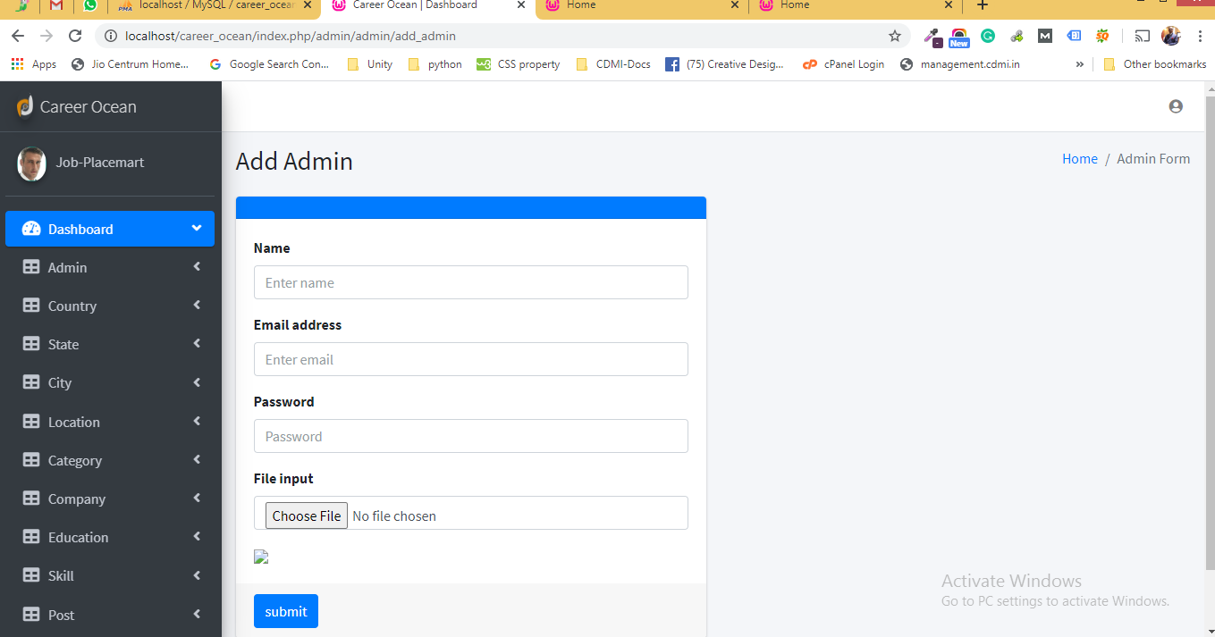

#### Change Password:

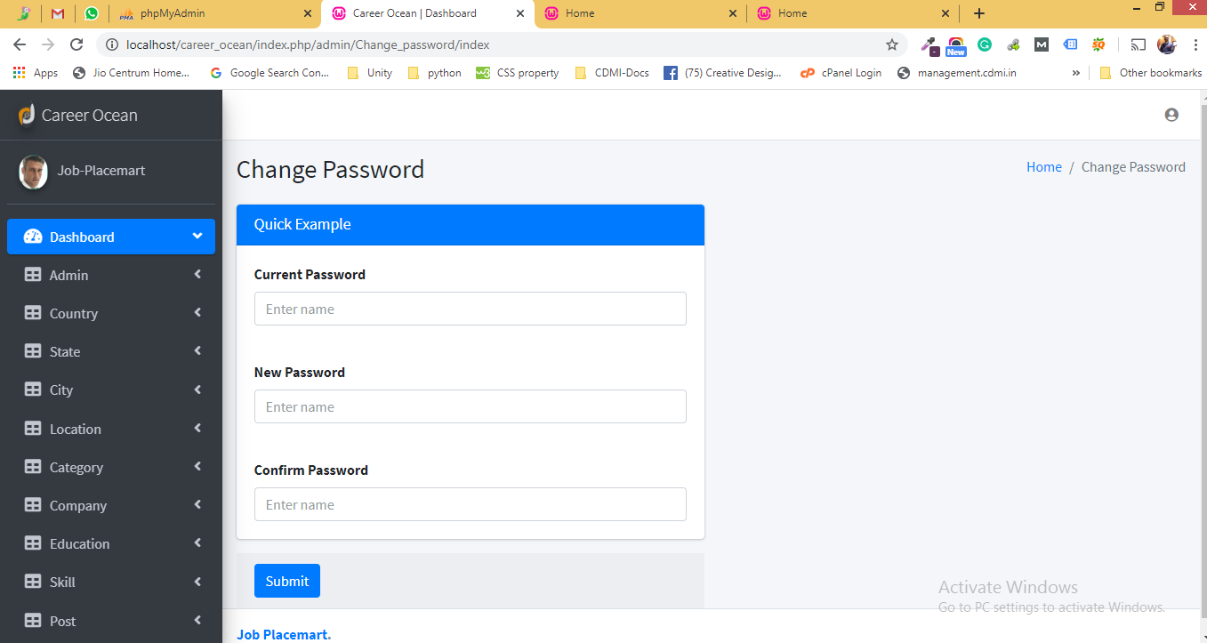

#### Data Tables :

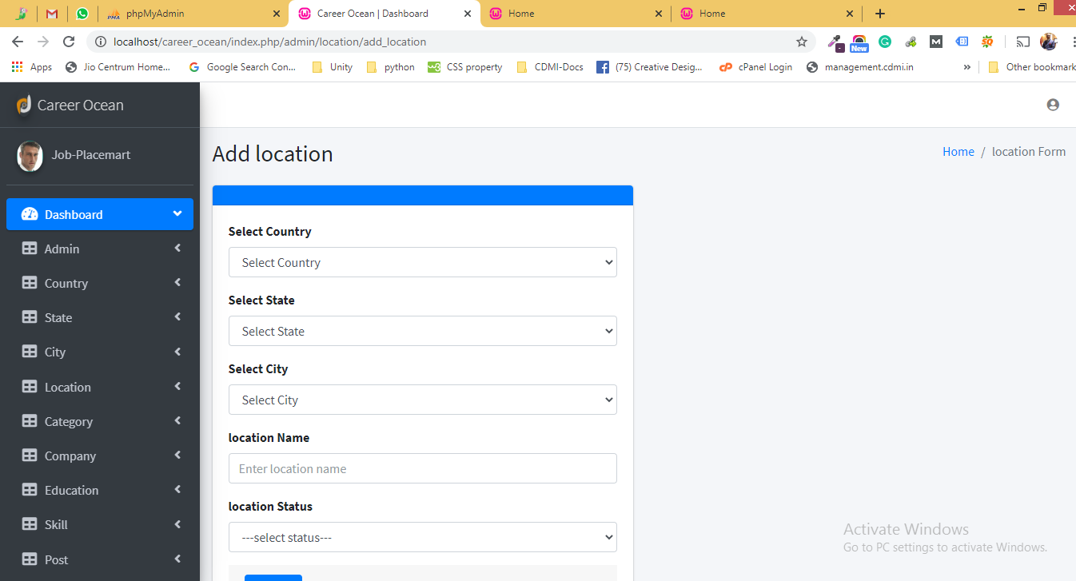

#### Add Company Table:

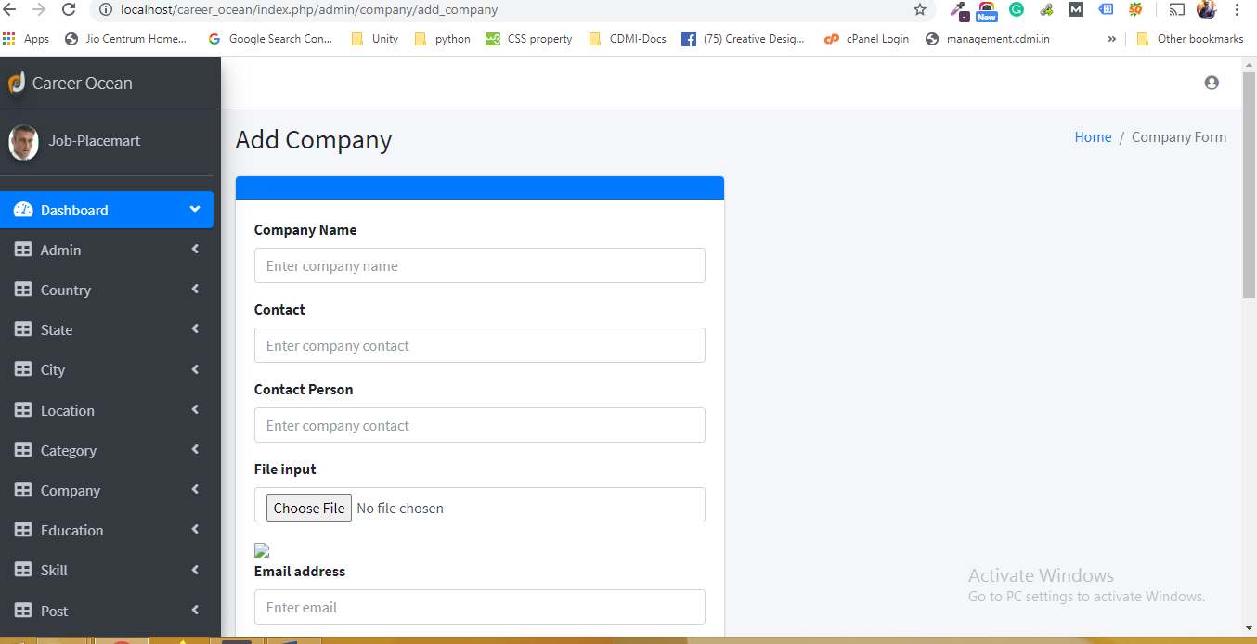

#### Education Tables:

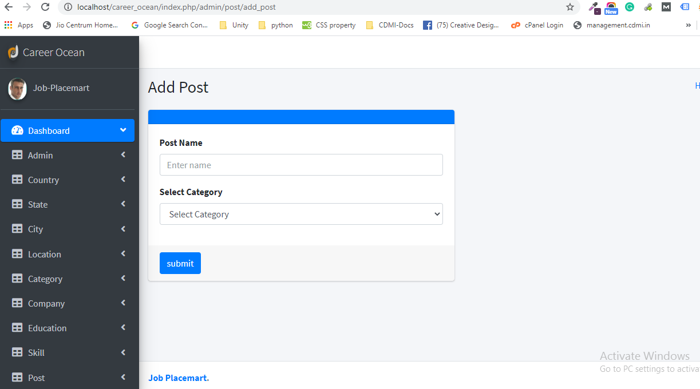

#### Post Tables:

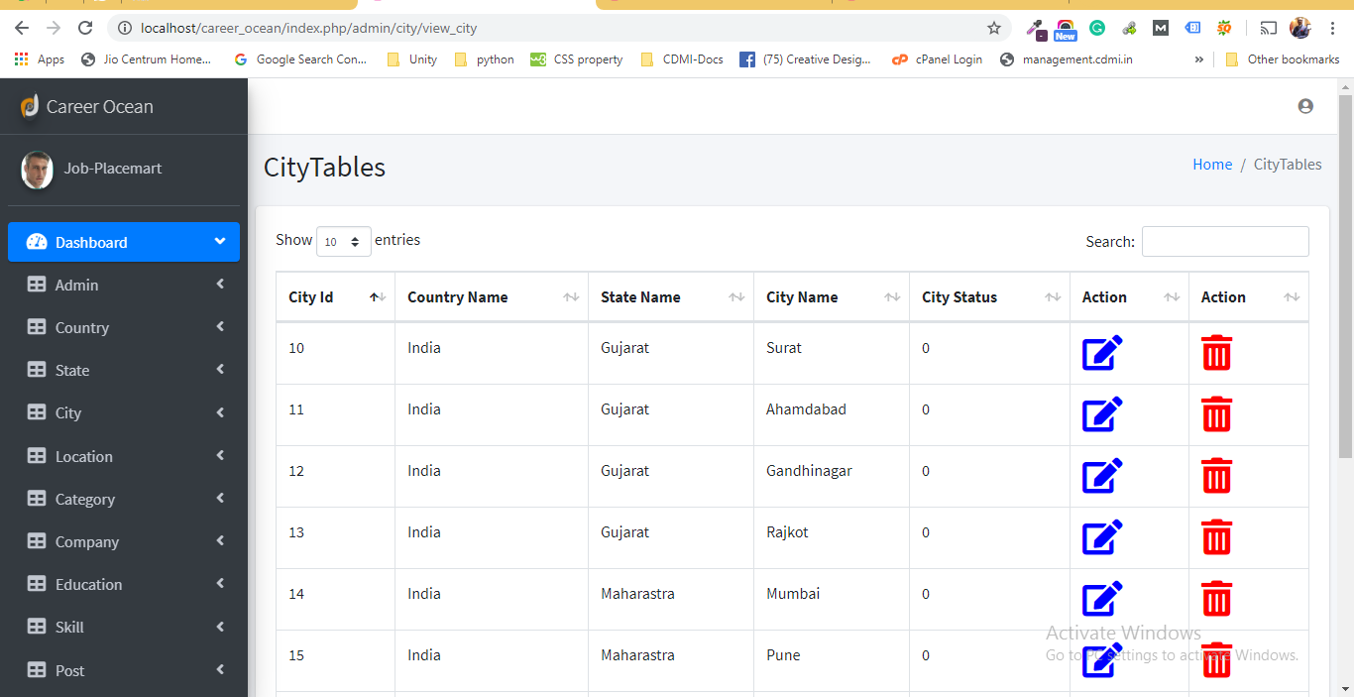

### Company Admin Side :

#### Company login Page:

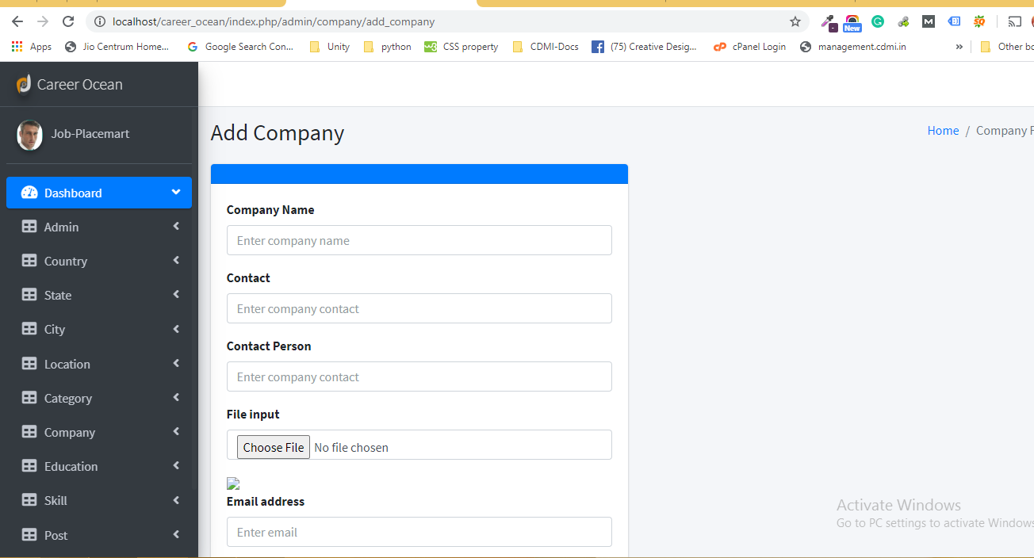

#### Company Dashboard:

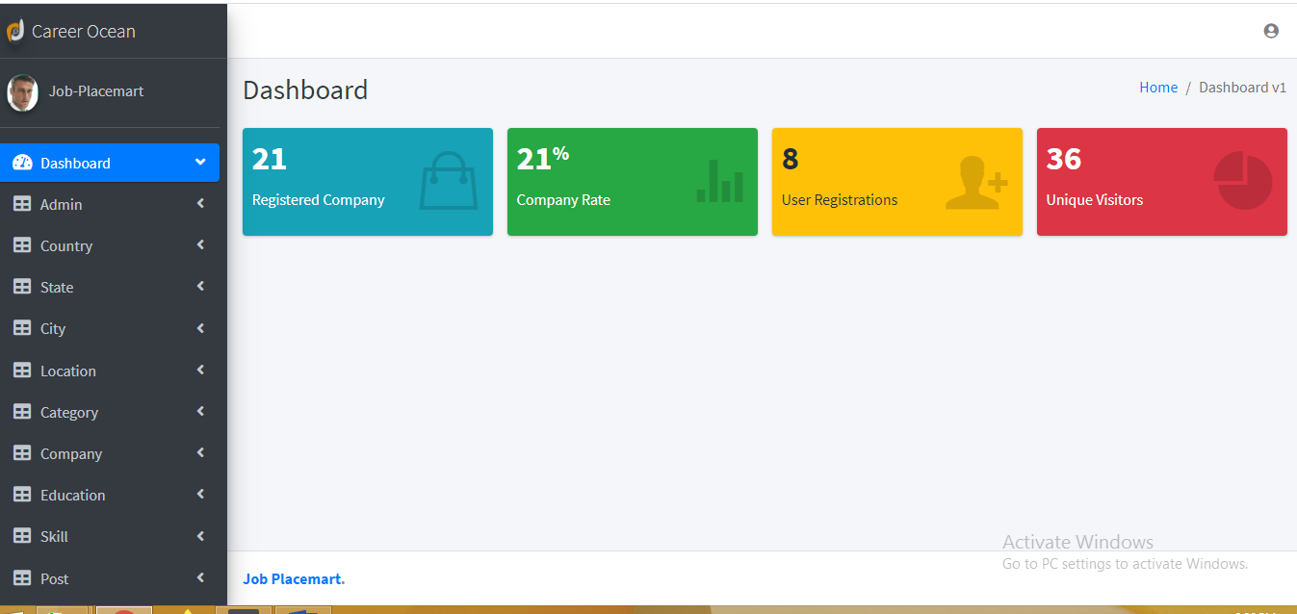

#### Edit Profile:

#### 

#### Change Password:

#### 

#### Company Detail :

c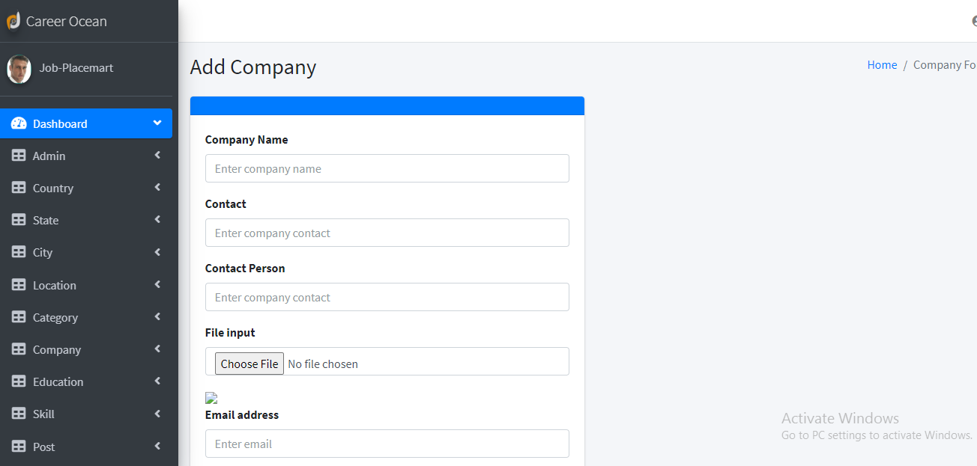

#### Buy Package:

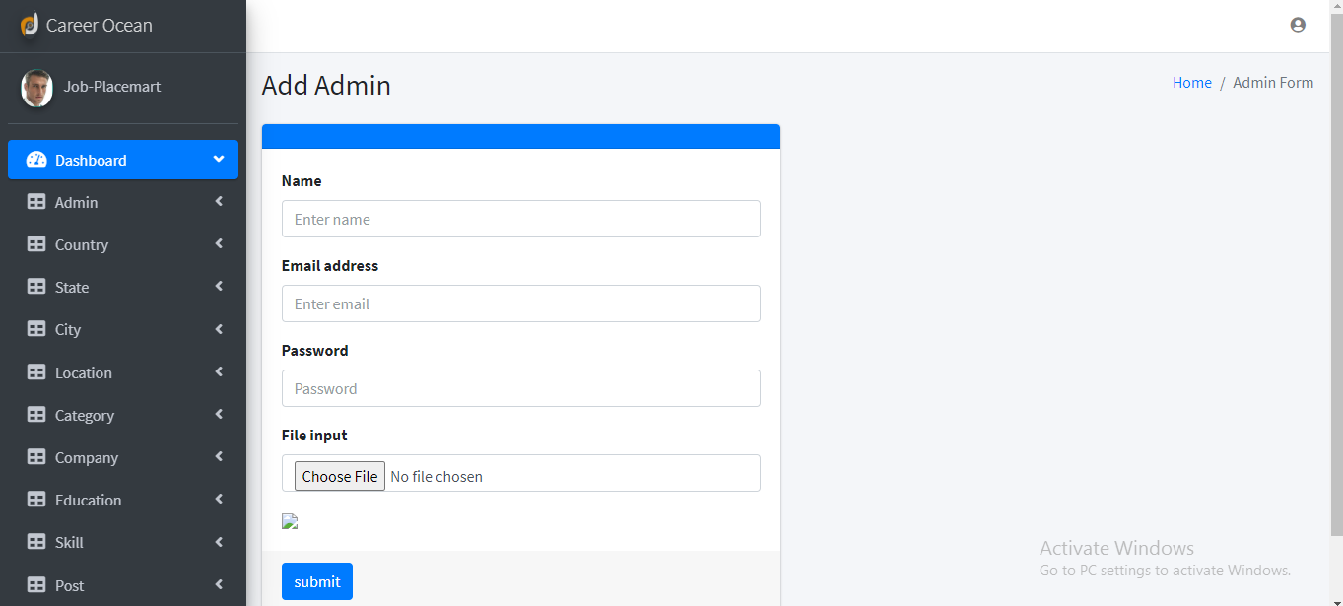

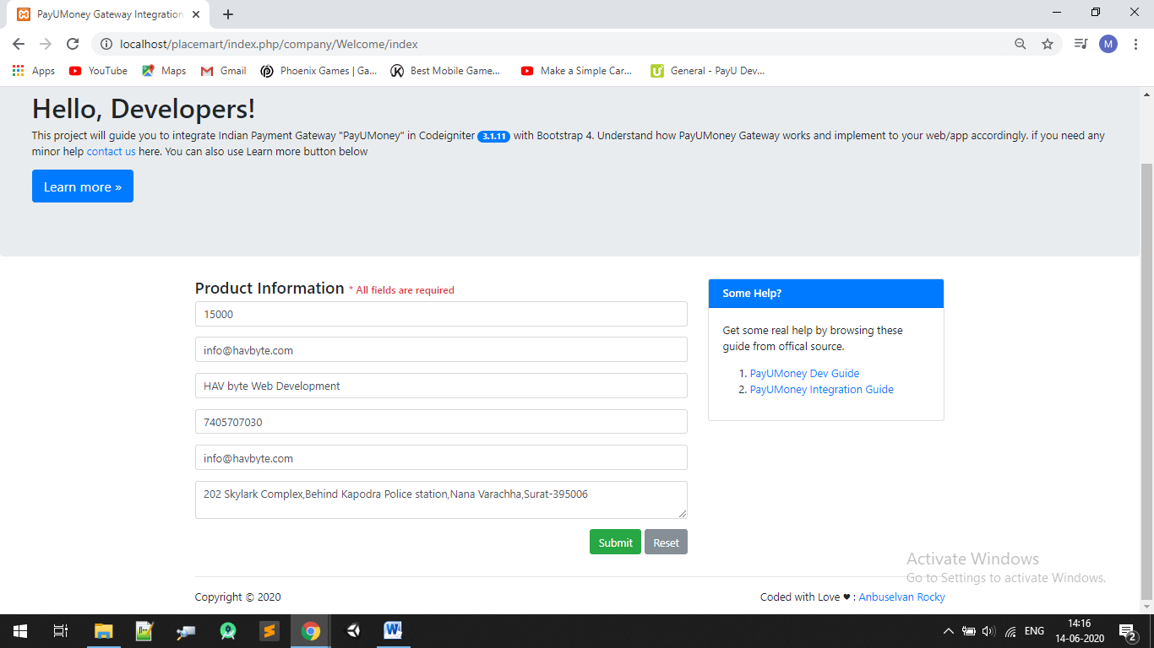

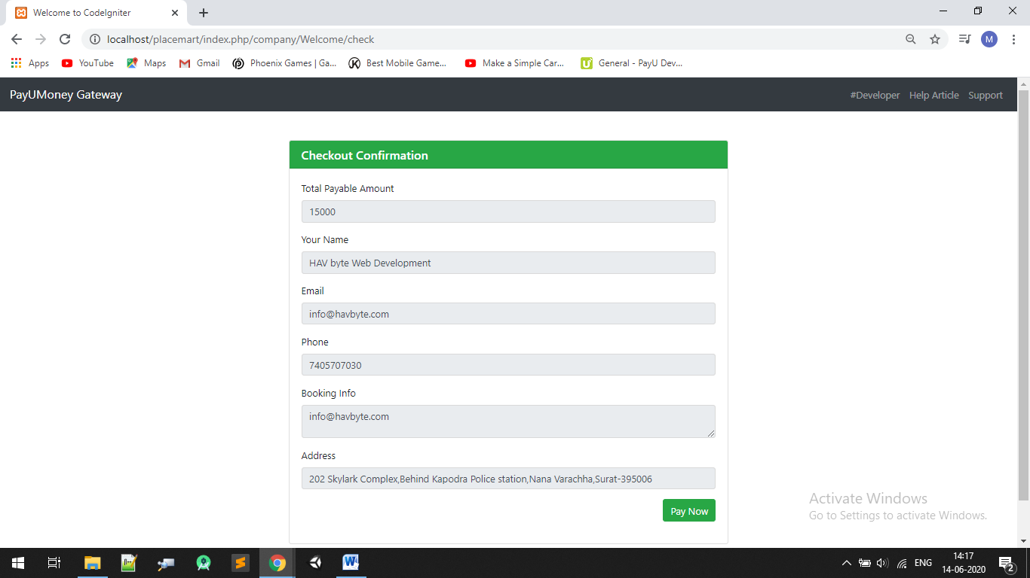

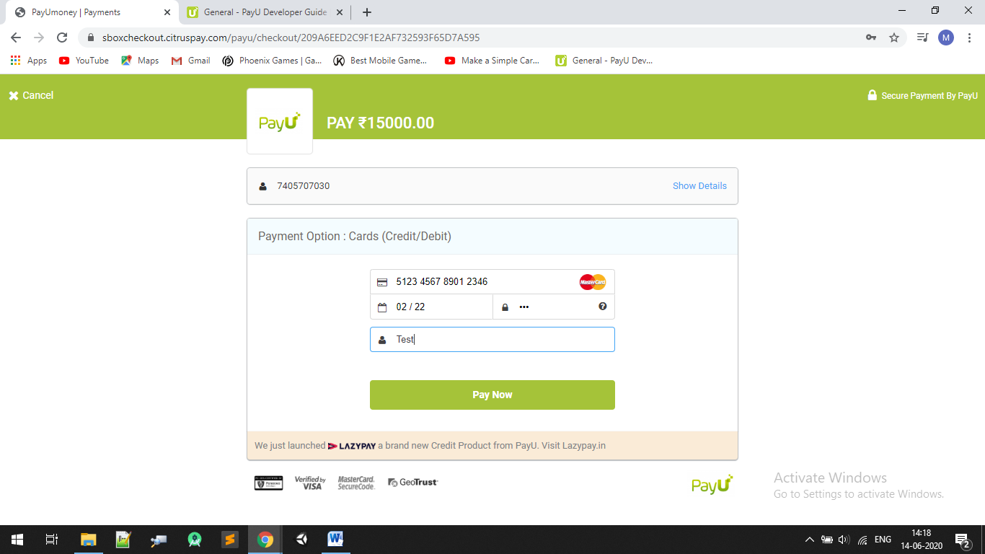

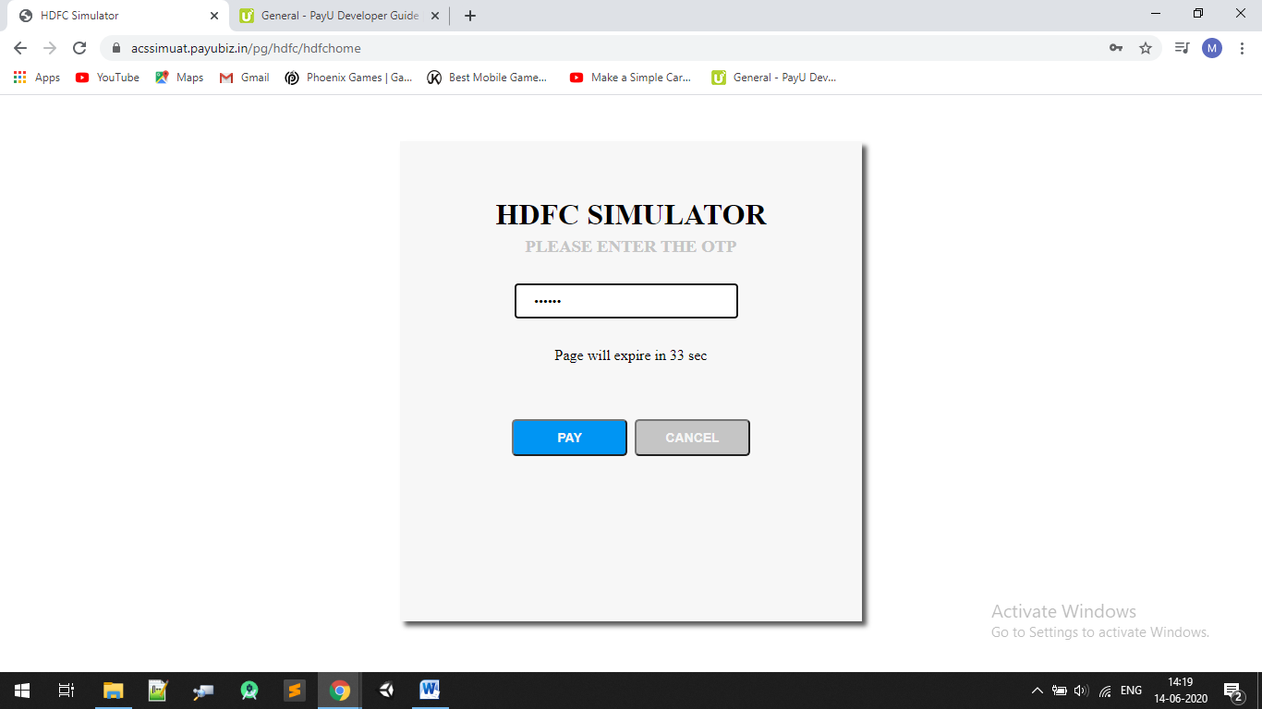

#### 

#### Testimonial Tables:

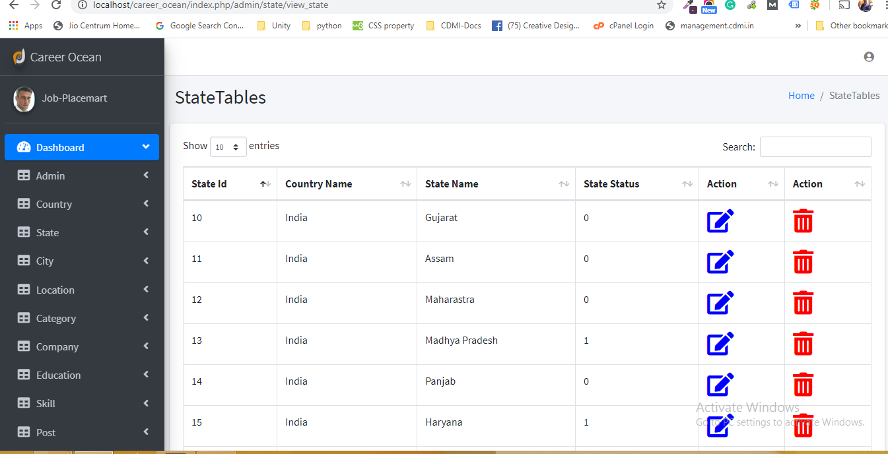

**9. SOFTWARE TESTING**

**9.1 Software Testing**

**9.2 Test case**

## 9.1 Software Testing

## 1 Software Testing :

#### Software testing is a critical element of software quality assurance and represents the ultimate review of specification design and coding. Testing is an exposure of a system to trial input to see whether software meets correct output. Testing cannot be determined whether software meets user’s needs, only whether it appears to confirm to requirements. Testing can show that a system is free of errors, only that it contains error. Testing finds errors, it does not correct errors. Software success is a quality product, on time and within cost. Through testing can reveal critical mistakes. Testing should therefore,

* Validate Performance.
* Detects errors.
* Identify.
* Inconsistencies
* **Test Objective:**

There Is Strong Evidence That Effective Requirement Management Leads To Overall Project Cost Savings. The Three Primary Reasons For This Are:

* Errors in requirement typically cost over 10 times more to repair than other errors.
* Requirement errors typically comprise over 40% of all error in a software project.

The Testing Procedure Should Care For All Of These, As Well As, In Order To Attain A Flawless, Error-Free And Efficient Functioning System; Too, Software Testing Is An Important Phase Of Any Software Development Life Cycle. Various Reports And Data Used For The Same Are The Core Of The System. The Testing, Therefore, Becomes Important In Order To Maintain The Cost As Well As Improve Performance And Consistency. The Testing Procedure For The System Has Been Divided In To Various Parts Ranging For Single Unit Testing To Entire System Testing.

**2.Unit Testing :**

* In unit testing Module is tested separately and the programmer simultaneously along with the coding of the module performs it.
* In unit testing the analyst tests the programs making up a system. For this reason, unit testing is sometime called program testing. Unit testing gives stress on modules independently of one another, to find errors. This helps the tester in detecting errors in coding and logic that are contained within that module alone. The errors resulting from the interaction between modules are initially avoided.
* Unit testing can be performed from the bottom up, Starting with smallest and lowest-level modules and proceeding one at a time., for each module in Bottom-up testing a short program is used to execute the module and provides the needed data, so that the module is asked to perform the way it will when embedded within the larger system.

**3. System Testing :**

* This is performed after the system is put together. The system is tested against the system requirement to check if all the requirements are met and if the system performs of specify by the requirements.
* Testing is an important function to the success of the system. System testing makes a logical assumption that if all the parts of the system are correct, the goal will be successfully activated. Another reason for system testing is its utility as a user-oriented vehicle before implementation.

## 9.2 Test case

**System Testing Consists of Following Five Steps:**

1. **Program Testing :**

* A program represents the logical elements of a system. For a program to run satisfactorily, it must compile and test data correctly and tie in properly with other programs. It is the responsibility of a programmer to have an error free program. At the time of testing the system, there exist two types of errors that should be checked. These errors are

a) Syntax error

b) Logic error

* A syntax error is a program statement that violates one or more rules of the language in which it is written. An improperly defined field dimension or omitted key words are common syntax errors. These errors are shown through error messages generated by the Computer.
* A logic error, on the other hand, deals with incorrect data fields out of range items, and invalid combinations. Since the logical errors are not detected by compile, the programmer must examine the output carefully to detect them.
* When program is tested, the actual output is compared with the expected output. When there is a discrepancy, the sequence of the instructions, must be traced to determine the problem. Breaking the program down into self- contained portion, each of which can be checked at certain key points, facilitates the process.

1. **String Testing :**

* Programs are invariably related to one another and interact in total system. Each program is tested to see whether it confirms to related programs in the system. Each part of the system is tested against the entire module with both test and live data before the whole system is ready to be tested.

1. **System Testing :**

System testing is designed to uncover weaknesses that were not found in earlier tests. This includes forced system failure and validation of total system, as its user in the operational environment will implement it. Under this testing, generally we take low volumes of transactions based on live data. This volume is increased until the maximum level for each transaction type is related. The total system is also tested for recovery and fall back after various major failures to ensure that no data are lost during the emergency.

**10.LIMITAION & ENHANCEMENT**

**10.1 Limitations**

**10.2 Future Enhancement**

**10.1 LIMITATIONS**

* Without the proper knowledge user cannot use this website.
* Internet must be required for use this system.
* Registration should be required for use this system.

**10.2 FUTUR EANHACEMENT**

* Provide More Security.
* Online interview Provide

# 11. REFERENCE

#### <https://www.naukri.com/>

#### <https://www.indeed.co.in/>